REPORT

ON

THE TRAINING WORKSHOP
FOR THE NEWLY POSTED AND OTHER STAFF OF THE KRACHI WEST MUNICIPAL ASSEMBLY
ON THE LGS ACT, 2016 (ACT 936), LOCAL GOVERNMENT SERVICE PROTOCOLS, MMDA BYE LAWS AND OTHER RELEVANT ENACTMENTS

ORGANISED
BY

KRACHI WEST MUNICIPAL ASSEMBLY
(HUMAN RESOURCE DEPARTMENT)

Phone: +2330552725222
Email: krachiwestmunicipalassembly@gmail.com
Web: www.krachiwestmunicipalassembly.gh.com

19TH- 20TH SEPTEMBER, 2024

Table of Contents
1.0 INTRODUCTION 3
1.1 Background 3
1.2 The Training Objective and the Expected Outcomes 4
1.2.1 The Training Objective 4
1.3 Approach and Methodology 4
1.4 Workshop Participants, Venue and Date 5
1.5 Training Workshop Facilitators 5
1.6Training Workshop Materials 5
1.7 The Content of the Training 5
2.0 TRAINING WORKSHOP PROCEEDINGS 6
2.1 Training Workshop Day 1 6
2.2 Training Workshop Day 2 8
3.0 KEY COMMENTS AND CONCERNS 10
4.0 EVALUATION OF THE TRAINING WORKSHOP 11
5.0 RECOMMENDATIONS AND CONCLUSION 14
5.1 Recommendations 14
5.2 Conclusion 15
APPENDICES 15
Appendix 1: List of Participants 15
Appendix 2: Pictorial Evidence of the Training 21

1.0 INTRODUCTION

1.1 Background
The present-day Krachi West Municipal Assembly with Kete-Krachi as the capital town is the remnant of the former Krachi District which was created since the beginning of the current decentralization programme in 1988. The Administrative and Political jurisdiction of the former Krachi West District has since undergone remarkable changes. The then Krachi District was re-established by Legislative Instrument 1501 (L.I.1501) on March 10, 1989, after Jasikan and Nkwanta Districts were carved out of it.

To ensure an efficient and effective public administrative system, Ghana has been implementing a decentralization program since the 1980s. The Provisional National Defense Council (PNDC) embarked on the most ambitious local government reform program with a commitment to decentralization in 1988 (Ahwoi, 2010). According to Antwi-Boasiako (2010), “for public administrators to be seen as effective and productive, their area of administration must be politically and clearly defined hence the importance of decentralization”. Ayee (2008) argues that in Ghana, after independence, governments have preoccupied themselves with decentralization because they considered it as an essential condition for achieving socio-economic development and their political objectives such as the recentralization of power and legitimacy.

Under the decentralization system, district assemblies (local governments) are the highest political, decision-making, planning, budgeting, and executing body at the local level. Decentralization process is the wheel for driving the social and economic development of the local communities. In other words, local authorities (District/Municipal Assemblies) are mandated to ride on the wheels of the decentralization policy for the development of local communities. In Ghana’s decentralization program, District/Municipal Assemblies are endpoints of decentralized functions. According to Ahwoi (2010), the objective of decentralization is to transfer functions and powers through political decentralization; to transfer skills and competencies through administrative decentralization and decentralized planning, and to transfer means and resources through fiscal decentralization.

The key recipients of decentralized powers are the Local Government. Political, administrative, planning and fiscal authorities are transferred from individuals or agencies at the central government to other individuals or agencies at the local level who are closed to the people to be served. Local governments are expected to express and meet the wants of the local communities; and, to deliver services and promote sustainable development.

The Local Governance Act, 2016 (Act 936) is the main legislation governing administrative decentralization. Administrative decentralization at the centre involves ministerial restructuring and at the local level involves the establishment of decentralized Departments of the Regional Coordinating Councils (RCCs) and Metropolitan, Municipal and District Assemblies (MMDAs). Several sectors of the national level administration have been decentralised (first schedule of Act 936).

Article 192 (2) of the 1992 Constitution provides that the Civil Service, until provision is otherwise made by Parliament, comprises service in both central and local government. Local Government Service Act, 2003, Act 656 now replaced by the Local Governance Act, 2016 (ACT 936) created the Local Government Service (LGS) out of the Civil Service. The objective for the establishment of the LGS is “to secure the effective administration and management of the decentralized local government system in the country”. (LG ACT 936, Section 51). The LGS is responsible for the Administrative Decentralization. The Service requires a set of protocols, code of conduct, principles, core values and acceptable ethical standards to guide its membership and stakeholders for effective performance and delivery of quality service. It is in this regard that the Service has developed protocols and code of conduct to promote the values and beliefs of the Service amongst its entire membership.

To apprise newly posted and other staff of the Krachi West Municipal Assembly about the protocols, the LGS Act, 2016 (Act 936) and the code of conduct of the Local Government Service, the Municipal Assembly decided to organised a two-day training workshop for its staff at its Assembly Hall from 19th to 20th September, 2024.

1.2 The Training Objective and the Expected Outcomes

1.2.1 The Training Objective
The objective of the training was to sensitize newly posted staff of the Municipal Assembly on the content of the Protocols, the LGS Act, 2016 (Act 936) and the Code of Conduct of the Local Government Service.

1.2.2 The Expected Outcomes
It was expected that by the end of the training, participants would have:
- Been well equipped with knowledge on Decentralization and Local Governance in Ghana.
- Understood the local government service protocols, the lGS Act, 2016 (Act 936) and the code of conduct.
- Understood the roles and responsibilities of staff of Local Government Service to the District/Municipal Assemblies.
- Understand the political and organizational dynamics of local government in Ghana

1.3 Approach and Methodology
The training adopted participatory approach to all activities during the training workshop. To ensure quick and more lasting results, participants were actively involved in the training activities from the beginning to the end.

The training comprised a combination of power point presentation, questions, and answers, brainstorming and plenary discussions, and experience sharing on key issues.

1.4 Workshop Participants, Venue and Date
A total of Nineteen (19) persons attended the training workshop. The participants comprised Fourteen (14) males and Five (5) females. Day one (1) of the workshop was attended by nineteen (19) participants whilst day two was attended by the same number of participants, which represent a hundred percent attendance. The list of participants can be found in appendix one (1) of this report.

The training was organized at the Assembly Hall of the Krachi West Municipal Assembly from the 19th of September, 2024 to the 20th of September, 2024.

1.5 Training Workshop Facilitators
The training workshop was facilitated by the Municipal Human Resource Manager and the Municipal Coordinating Director. The team comprised Mr. Alhassan Hamza, the lead facilitator; and Mr. Bright Akompim, the rapporteur.

1.6Training Workshop Materials
The training was designed such that participants were actively involved in every aspect of it. To achieve the set objectives, the following materials were used:
- Power point slides
- Handouts
- Overhead projector
- Laptop computer
- Flip chart sheets
- Flip chart board
- Markers
- Food and drinks

1.7 The Content of the Training
The training was basically on Decentralization, Local Government and the protocols and code of conduct of the Local Government Service. The key contents of the training workshop included:
- Introduction to Decentralization.
- Local Government and Local Government Service.
- The establishment of the Decentralized departments and the MMDAs.
- Local Government Service Protocols.
- Local Government Service Code of Conduct.

2.0 TRAINING WORKSHOP PROCEEDINGS
The training workshop was organized for two days at the Assembly Hall of the Krachi West Municipal Assembly at Kete-Krachi in Oti Region. The training commenced on the 19th of September, 2024 and ended on the 20th of September, 2023.The following illustrates the proceedings of the training workshop.

2.1 Training Workshop Day 1
The day one (1) of the training started at exactly 10:00 am at the Krachi West Municipal Assembly Hall. It was attended by Nineteen (19) newly posted staff of the Municipal Assembly comprising fourteen (14) males and five (5) females.

The session began with an opening prayer by Mr. Mornyuie Worlanyo Gogo, an Environmental Health Officer of the Municipal Assembly. Facilitators welcomed participants after they had introduced themselves and assured them of a fruitful training session. Participants were then asked to introduce themselves by mentioning their names and designations.

After the introduction of participants, the rules governing the training workshop were set up after which the class representative was elected to provide logistical and timekeeping support, among others. Participants were subsequently taken through the workshop objectives and expectations. The lead facilitator, Mr. Alhassan Hamza, indicated that the objective of the training was to provide orientation on decentralization, local governance, and the Local Government Service. The training was also intended to explain the various protocols of Local Government Service and the code of conduct to the understanding and appreciation of participants.

To facilitate active participation of all participants, participants were given the chance to mention their expectations for the training. Participants expected that by the end of the training they would be able to:
- Deepen their understanding of Decentralization and Local Government.
- Know and understand the Local Government Service Protocols and the Code of Conduct.
- Deepen their understanding of the functions of the Local Government Service and Municipal/District Assemblies.

The lead facilitator took participants through the background of decentralization policy in Ghana. Among others, the facilitator noted that the decentralization policy was heighted by the then Provisional National Defense Council (PNDC) in the 1980s. He indicated that the PNDC embarked on the most ambitious local government reform programme with a commitment to decentralization in 1988. He said that the idea for the decentralization policy was that so much power, and authority was centered at the top (central government) and therefore there was the need for power and authority, skills and expertise, and resources to be transferred from the central government to the local government structures. The facilitator mentioned that the PNDC government believed, among others, that decentralization would facilitate involvement of the local people in the governance of the local people, and to help identify local needs and design appropriate policies, programs and projects to address them. Similarly, the facilitator indicated that one of the ideas for decentralization was to ensure that local people were empowered to identify and address local development issues. It was also meant to ensure bottom-up approach to development rather than top-down approach where people sit in their offices in the cities and develop policies, programs, and projects for local people. The facilitator further indicated that the commitment of the PNDC was transferred to the 1992 Constitution which has Chapter 20 devoted to “Decentralization and Local Government”. He therefore defined Local Government as government for the local people and by the local people.

After satisfactory explanation of decentralization and Local Government, the facilitator took participants through the following:
- Main reasons for decentralization
- The five main interrelated pillars of decentralization (political decentralization, administrative decentralization, decentralized development planning and budgeting, fiscal decentralization, popular participation, and accountability).
- History of Local Government Service
- The Local Government Act, 2016 (Act 936)
- Objective for the establishment of Local Government Service
- Membership of the Local Government Service
- Strategic direction and functions of the Local Government Service
- Organograms of the office of the Head of the Local Government Service and the Regional Coordinating Councils (RCCs).
- Compositions and the roles of the RCCs.
- Key functions of MMDAs
- Local Government Service protocols
- Local Government Code of Conduct.

The facilitator laid much emphasis on the Local Government Service Protocols and the Code of conduct. He took time to explain the areas of the code of conduct such as the hours of work; promotions, training, and development; Leave (study leave with pay and bond periods); postings and movement within the service, discipline, the principles (canons) of the code of conduct, among others.

Similarly, the facilitator explained the reporting procedure under the Local Government Service. He indicated among others that report of breaches of the code of conduct may be lodged in ascending order such as:
- Immediate superior of the complainant
- Head of Department/Unit
- The District/Municipal Coordinating Director
- The Regional Coordinating Director
- Head of Service
- The Local Government Service Council

After the presentations, participants were given the opportunity to ask questions, make inputs and suggestions, or comments on the presentations. The day one (1) training ended at 5:00 pm with a closing prayer by Bernard Kelly, Assistant Director IIB.

2.2 Training Workshop Day 2
Day two of the training workshop was attended by Nineteen (19) participants comprising Fourteen (14) males and Five (5) females. Participants included the Newly Posted Staff, casual workers, cleaners, and laborers of the Municipal Assembly. The training started at 9:30 am with a prayer. As a result of the involvement of low-level staff of the Assembly, the language of instruction was mixed with English and Twi. The facilitator did well to use both English and the Twi language throughout the discussions and the presentations.

The day two’s activities began with a recap of day one’s activities. To ensure active participation of all participants, each participant was asked to mention at least one thing she or he could remember from day one’s training activities. Responses from participants indicated that they understood and appreciated the day one’s training activities. The following were some of the new things participants indicated they learnt from day one’s training:
- The code of conduct of the Local Government Service.
- The working hours of the Local Government Service (start work at 8:00 am and close at 5:00 pm).
- The definition of decentralization (transfer of power and authority, skills and functions, resources from the centre to the local level structures and individuals).
- Canons of the code of conduct of the Local Government Service.
- The Organizational structure or organogram of the Local Government Service and the Regional Coordinating Councils.
- The local Government protocols.

The facilitator took time to explain salient portions of the code of conduct and the protocols of the Local Government Service. Specifically, participants were taken through the working hours; the canons (principles) of the code of conduct; roles and responsibilities of district assemblies to the community. They were advised to adhere to the principles of the code of conduct to avoid breaches and possible sanctions from their employer (Local Government Service).

Similarly, participants were advised to take their employment serious, be diligent and work with integrity. They were reminded to always remember that their employment was governed by rules and regulations, and that their efforts would be rewarded in the future if they worked diligently.

Participants were also advised to adhere to the reporting order as indicated in the Code of Conduct and not to take the law into their own hands. The facilitator ended day two activities with quotations from renowned personalities. They included the following:

- DON’T FIND FAULT, FIND REMEDY- HENRY FORD
- BE THE CHANGE YOU WANT TO SEE-GHANDI
- WE ARE WHAT WE REPEATEDLY DO. EXCELLENCE THEN, IS NOT AN ACT, BUT A HABIT- ARISTOTLE

The facilitator used the above quotations to advise participants to work hard, be committed to their work, and work with integrity to serve their clients (Krachi-West Municipal and communities).
Participants were encouraged to set goals, take advantage of opportunities available to them, and always keep their eyes on the bigger picture.

Training manuals and handouts were shared with the participants after the presentations. They were advised to go through the training materials to deepen their understanding of the knowledge they had acquired from the training. Day two’s activities ended at 2:30 pm with a closing prayer by Mr. David Tsekpo.

3.0 KEY COMMENTS AND CONCERNS
After the proceedings, participants were asked to come out with their comments and concerns. The following were some of the key comments and concerns raised by participants.

- “Until this training, we did not know it was mandatory for staff to start work at 8:00 am; break for lunch at 12:30 pm to 1:30 pm; and close from work at 5:00 pm”.
- “I did not know that no acting assignment shall exceed a period of one year”.
- “We have been in employment for more than one year, but we did not have knowledge of the Condition of Service and the Code of Conduct of the Local Government Service until now”.
- “This is the first time I am being trained after being employed by the Municipal assembly. I have learnt several things that I did not know before”.
- I did not know that in the discharge of my official duties if someone offends me or breaches any of the code of conduct, I have to report him/her to my immediate superior and wait for feedback within 14 days, rather than going to court”.
- “The municipal assembly has not been organizing staff durbars for staff to discuss concerns and updates on the development of the district”
- “There is no place of convenience for staff at the main administration block”.

4.0 EVALUATION OF THE TRAINING WORKSHOP
To assess the achievement of the training output, the facilitator asked the participants to assess the training workshop in the following areas:
- Overall Achievement of workshop objectives
- The extent to which the Workshop Expectations were met
- Pre-Workshop contact
- Facilitators Courtesy, Promptness and Delivery
- Workshop Materials
- Participation and Involvement of the Participants
- Venue and Meals

The following were the results of the evaluation:

Achievement Of Workshop Objectives
Eight (8) of the participants (42%) rated the achievement of the workshop objectives as excellent; Seven (7) participants (37%) rated it as very good; two (2) participants (11%) rated it as good; whilst two (2) participant (11%) rated it as fair. This indicated that the objectives of the workshop were achieved as depicted in Figure 1.

Figure 1: Overall Achievement of Workshop Objectives

Extent To Which Participants Expectations Were Met
Two (2) of the participants (12%) indicated that participants’ objectives were excellently met; eleven (11) participants (65%) rated the extent to which their expectations were met as very good; two (2) participants (11%) rated the extent to which their expectations were met as good, whiles one (1) participant rated the extent to which their expectations were met as fair. The responses signified that the overall expectation of the participants was met. Figure 2 shows a pictorial view of participants’ response to the extent to which their expectations were met.

Figure 2: Extent to Which Participants Expectations Were Met

Performance and Delivery
Figure 3 shows participants’ responses to the performance of the facilitator in terms of delivery, development of practical skills and impartation of knowledge. Participants described the training as practical, interactive, very insightful and successful. Eleven (11) of the participants (61%) rated the facilitation and delivery of the workshop as excellent, four (4) of the participants (22%) rated it as very good, two (2) participants (11%) rated it as good whilst one (1) participant (6%) rated it as fair. This shows that participants were satisfied with the performance and delivery of the training workshop.

Figure 3: Facilitation and Delivery

Participation and Involvement of Participants
Four (4) of the participants (22%) rated their level of participation and involvement as excellent; nine (9) of the participants (50%) rated their level of involvement and participation as very good, three (3) of the participants (17%) rated their level of involvement and participation as good, whiles two (2) of the participants (11%) rated their level of involvement and participation as fair. Figure 4 shows a pictorial view of responses on participation and involvement of participants.

Figure 4: Participation and Involvement of Participants

5.0 RECOMMENDATIONS AND CONCLUSION

5.1 Recommendations
The training workshop unraveled several areas within the municipal administration that could be improved to facilitate enhancement of public service delivery and work performance of staff. It is therefore recommended that:
- To monitor the attendance of staff, each department should have a logbook to record arrival and departure time under the supervision of heads of department.
- Staff performance appraisals should be conducted in a manner that will identify areas of weakness of low performing staff for training programs to be developed to improve their performance. Similarly, high performing staff should be incentivized to do more.
- Staff durbar should be organized periodically to discuss concerns of staff on relevant issues affecting their employment and work performance.
- A welfare scheme should be established to take care of warfare needs of staff within the Municipal Administration as required in the Local Government Service condition of service.
- Training and capacity building programs should be organized periodically for staff to improve their capacity and work performance.
- Information flow among staff within the municipal administration should be improved.
- More days should be allocated for such important training programs in the future.

5.2 Conclusion
The training was interactive, participatory, and successful. Through brainstorming, questions and answers, participants were actively involved from the beginning to the end. Participants were impressed with the outputs of the training as demonstrated in the evaluation.

It was observed that the training was an “eye opener” for most of the participants as they were exposed to the contents of the conditions of service and the protocols of Local Government Service for the first time in their employment.

APPENDICES

Appendix 1: List of Participants
No. | Name | Sex (M/F) | Position | Telephone | Email
1 | Alhassan Hamza | M | Mun. Coord. Director | 0242372665 | alhassnhamzolo@gmail.com
2 | Bright Akompem | M | Human Resource Manager | 0247772449 | brightakompim91@gmail.com
3 | Kelly Bernard | M | Asst. Director IIB | 0242916466 | bkelly@st.ug.edu.gh
4 | David Tsekpo | M | Asst. Director IIB | 0277552199 | davidtsekpo1@gmail.com
5 | Exorkey Delali Morgan | M | Snr. Information Techn. Technician | 0596421011 | morgandelali74@gmail.com
6 | Prince Osei | M | Technical Asst. | 0242738471 | princeosei@gmail.com
7 | Faustina Kafuri Nyasam | F | Account Officer | 246575490 | faustinanyasam@gmail.com
8 | James Kangele | M | Asst. Accountant |  | jameskangele@gmail.com
9 | Mprah Georgina | F | RMU Officer | 0243423977 | georgina@gmail.com
10 | Faustina Badu | F | Labourer | 0545504181 | faustinabadu@gmail.com
11 | Angela Quao | F | Secretary | 0247109753 | Angelaquao93@gmail.com
12 | Ahiabu Dennis Mawuli | M | Asst. Budget Analyst | 0245978941 | mawulidebis@gmail.com
13 | Ntumy Christiana | F | Asst. Chief Evn’tal Health Asst. | 0546253912 | Christianantumy72@gmail.com
14 | James Odum | M | Snr. Executive Officer | 0248815732 | jamesodum20@gmail.com
15 | Mornyuie Worlanyo Gogok | M | Environmental Health Officer II | 0557501721 | worlanyomornyuie6@gmail.com
16 | Nanabo Prosper | M | Environmental Health Officer II | 0546501590 | nanaboprosper@gmail.com
17 | Benjamin Dapaah | M | Procurement Assistant | 0248037876 | dapaahbenjamin5@gmail.com
18 | Adri Prosper | M | Central Administration | 0240520990 | prospera@gmail.com
19 | Godwin Dzakpasu Mawunyo | M | Asst. Budget Analyst | 0241273096 | godwindgm7@gmail.com
20 | Hon. Patrick Kwaku Bulator | M | Hon. MCE | 0249232514 | patrickkwakubulator@gmail.com
Appendix 2: Pictorial Evidence of the Training



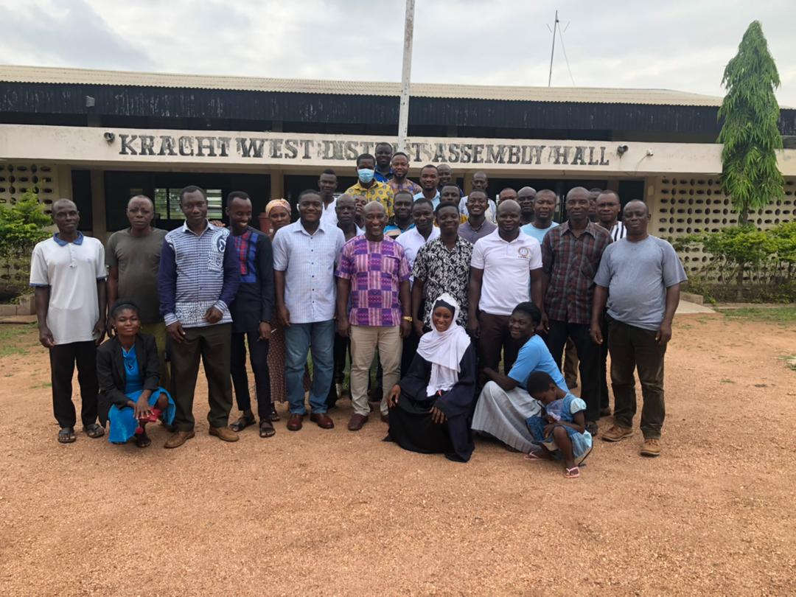

Group picture of workshop participants

ALHASSAN HAMZA BRIGHT AKOMPIM
(MUN. COORD. DIRECTOR/FACILITATOR) (MUN. HRM/RAPORTEUR)

Appendix 2: Pictorial Evidence of the Training

A section of workshop participants

Group picture of workshop participants

