KRACHI WEST MUNICIPAL ASSEMBLY
TRAINING FOR REGIONAL TRAINERS AND CSU OFFICERS ON THE NEWLY DEVELOPED LOCAL GOVERNMENT SERVICE (LGS) CLIENT SERVICE UNIT OPERATIONAL MANUAL

DATE: 13TH AND 14TH NOVEMBER, 2023

BY GHANA SECONDARY CITIES SUPPORT PROGRAM (GSCSP)

Table of Contents
1.0 Introduction 2
2.0 Objectives of the Training Workshop 4
2.0.1. Objectives (Specific) 4
3.0 Challenges facing the Client Service Unit of the MMDAs 4
4.0 The Decentralization Process 5
5.0 The Client Service Charter 5
6.0 Steps in Developing the Charter 6
7.0 Methodology 6
7.1. General discussions: 6
8.0 Questions session: 9
9.0 Location (Place of training, Workshop) 9
10.0 Dates and time / period of the training, 9
11.0 Describe the target group/s for the training 10
12.0 Describe the actual outcome/s of the training against the expected outcome/s 10
13.0 Provide a description of any evaluation activities undertaken and the conclusion 11
14.0 Compliments and Commendations 11
15.0 Challenges 12
16.0 Recommendations for future training activities 12
17.0 Conclusion: 13
Appendix I: Participants Evaluation of Workshop/Training: 14
18:0 SEX SEGREGATION 15

1.0 Introduction
The local government system has been widely credited as being the most effective form of governance that prompts the generation of key developmental plans from the grass root level through well-established structures, with the implementation also being with the active involvement of people at all levels of authority and development. The LGS geared towards establishing a system where the general public can receive information, make enquiries or lodge their complaints to the service through the MMDAs. With the MMDAs having the responsibilities to lead in the planning, implementation and evaluation of activities to promote effective development at the local level, it is crucial that they have the needed capacity to make them effective in their delivery and promote efficient outcomes.
In line with this goal, a Specific Operational Manuals have been developed by the Local Government Service on Client Service, which will serves as a guide towards a successful receipt of complaints, enquiries and how to address those issues to the satisfaction of Clients.
The Client Service Unit is one of the Units under the Central Administration Department of the Assemblies and the RCCs. At the Office of the Head of the Local Government Service, the Client Service Unit is a unit under the Administration Directorate. In respect of the MMDAs, the Unit fall under the Central Administration performing numerous functions such as receiving Complaints, enquiries and ensure that feedbacks are effectively managed within a standardized and approved framework. Service delivery and effective stakeholder management are key to organizational success.
In view of these, the Local Government Service in collaboration with Ghana Secondary Cities Support Program (GSCSP) decided to organize a Two-Day Training Workshop for Client Service Supervisors, Client Service Officers and MIS Officers from all the MMDAs across the Country.
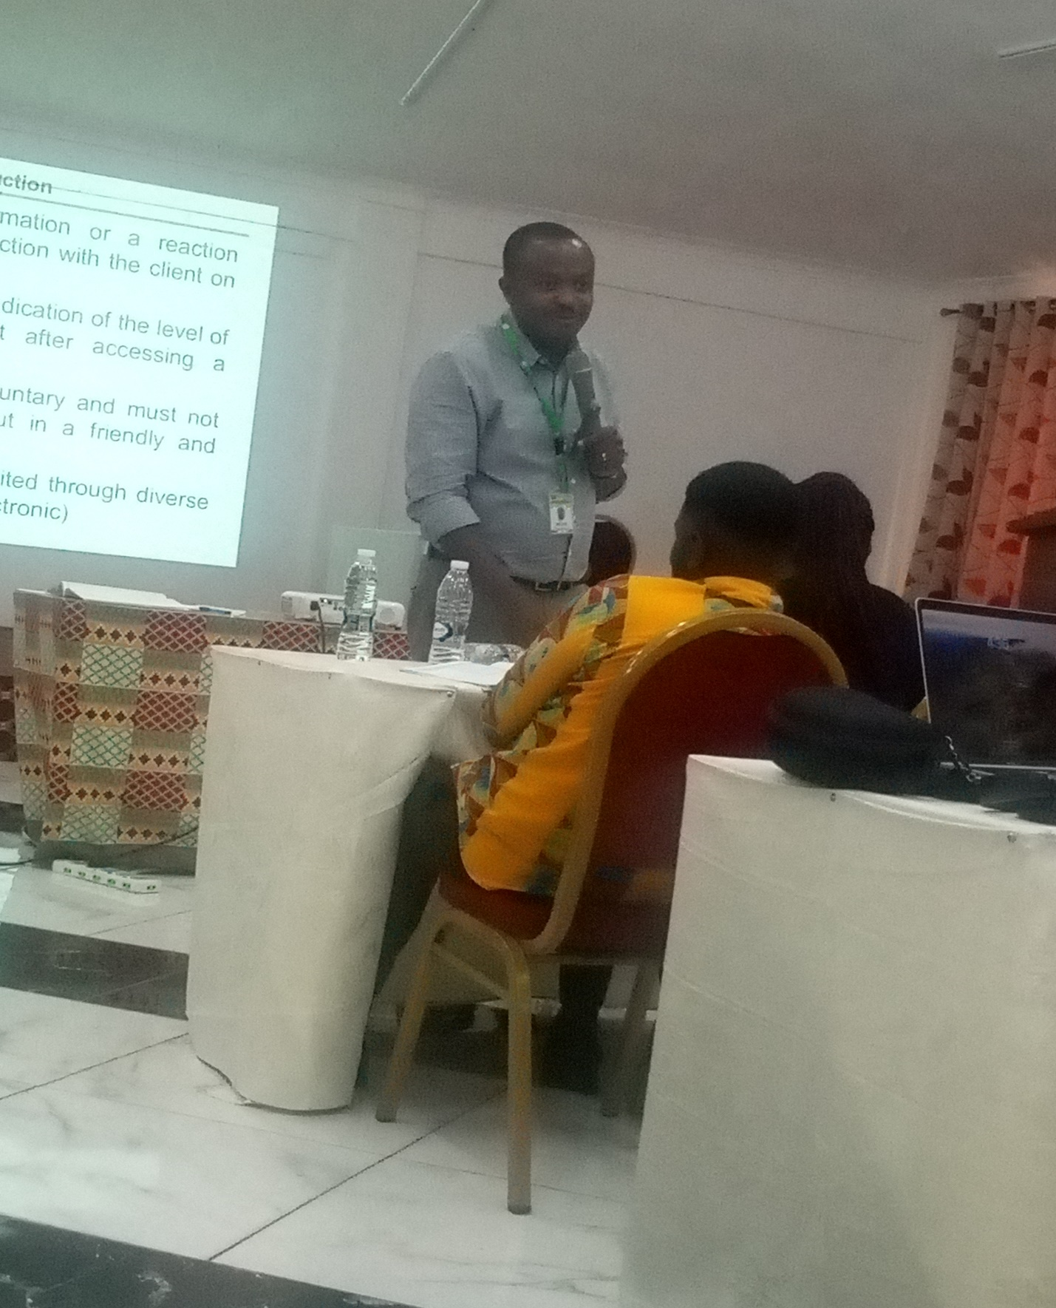
Figure I: Presentation by Engineer Baah

2.0 Objectives of the Training Workshop
The objective of the training is to provide the target group (Client Service Supervisor, Client Service Officer and the MIS Officer) with the required skills and knowledge in handling clients effectively. That is, providing a standardized procedure in receiving and handling complaints, enquiries and provide feedback.

2.0.1. Objectives (Specific)
- To make the participants understand how clients are taking care of in the Departments, divisions & units of the MMDAs and for that matter the LGS
- To equip participants with the knowledge of handling complaints and enquiries
- To provide timely feedbacks to clients as specified in the RTI Law

3.0 Challenges facing the Client Service Unit of the MMDAs
- Lack of clarity between and among the roles of a Receptionist, Client Service Unit and Public Relations and Complaint Committee
- The Client Service Unit is not duly recognized within the Local Government Service
- Lack of clarity and understanding of the functions, roles and responsibilities of the LGS institution by clients
- Lack of standardized complaints management procedure within the Local Government Service
- Inadequate human resource capacity for all the unit levels
- The client service unit function not seen as shared responsibilities
- High attrition of the Client Service staff
- Lack of dedicated class for the client service unit
- Lack of office accommodation for the Client Service Officers

4.0 The Decentralization Process
Participants were taken through the decentralization process, the types of decentralization and the responsibilities of the various Metropolitans, Municipal and District Assemblies (MMDAs) towards the implementation of the system.
According to the facilitate, there are three (3) main decentralization namely:
- Devolution, eg. District Assemblies.
- De-concentration, eg. Regional Coordinating Councils (RCCs)
- Delegation, eg. Transportation Authorities, Regional Development Corporations etc.
The facilitator also mentioned the six (6) thematic areas of the National Decentralization Policy and Strategy (2020-2024). These include
- Political Decentralization
- Administrative Decentralization
- Decentralized Planning
- Fiscal Decentralization
- Local Economic Development
- Popular Participation
Finally, the three different levels of government were discussed. These include:
- Central Level (Ministries, Departments and Agencies)
- Regional Level (Regional Coordinating Councils)
- Local Level (MMDAs)
In conclusion, participants were urged to embrace the decentralization system as the Client Service Unit will operate based on the decentralization system.

5.0 The Client Service Charter
Participants were taken through the preparation of the Client Service Charter, which is a mandatory document for the Client Service Unit. That, the Charter highlight the activities of the client service unit, the services rendered, the procedures, how complaints and enquiries are handled, the timelines and so forth.
Each Assembly was tasked to come out with a well-organized Client Service Charter.
Here, a service charter normally consist of the following:
- A guide to your service
- Statement of the rights and responsibilities of the clients
- Standards of service you aim to achieve
- A formal complaint procedure for resolution of complaint.

6.0 Steps in Developing the Charter
- Composition of the Committee
- Apply the Dos and Don’ts
- Apply the templates
- Validation of the Charter

7.0 Methodology
The training adopted a variety of methods in its delivery processes to include:
- Facilitation and presentations
- Syndicate group discussions/presentations
- Brainstorming and Stimulation
- Institutional experience sharing
- Case studies and best practices
Key and responsible individuals, particularly supervisors briefing

7.1. General discussions:

Generally, the workshop adopted other training and learning methods and used adult learning techniques to equip participants with basic skills, knowledge and in some cases, behavior change they may need to perform their duties and responsibilities for increased productivity. A mixed of this method that was applied are:
- A participatory learning approach to allow free expression of opinion;
- Lectures: this methodology was used to introduce the subject matter and allow deeper discussion of issues in relation to client service.
- Questions and Answers approach was also used to tease out important issues in effective client service processes, and best practice approach to dealing with such issues.
- Participants were also put into groups (Based on Assemblies) to share and contribute to discussion questions.
- Discussions were also used to promote adult learning and sharing of relevant information
Some of the discussion questions include:
- What are the procedures in handling clients
- What are the roles of the Client Service Supervisor, the Client Service Officer and the MIS Officer?
- How do we handle visitor’s complaints and concerns?
- Who is a Client?
- The linked between the Client Service Activities and the RTF Law
- How to use the Visitors Complaint Book and the Complaint Form?
and so forth.
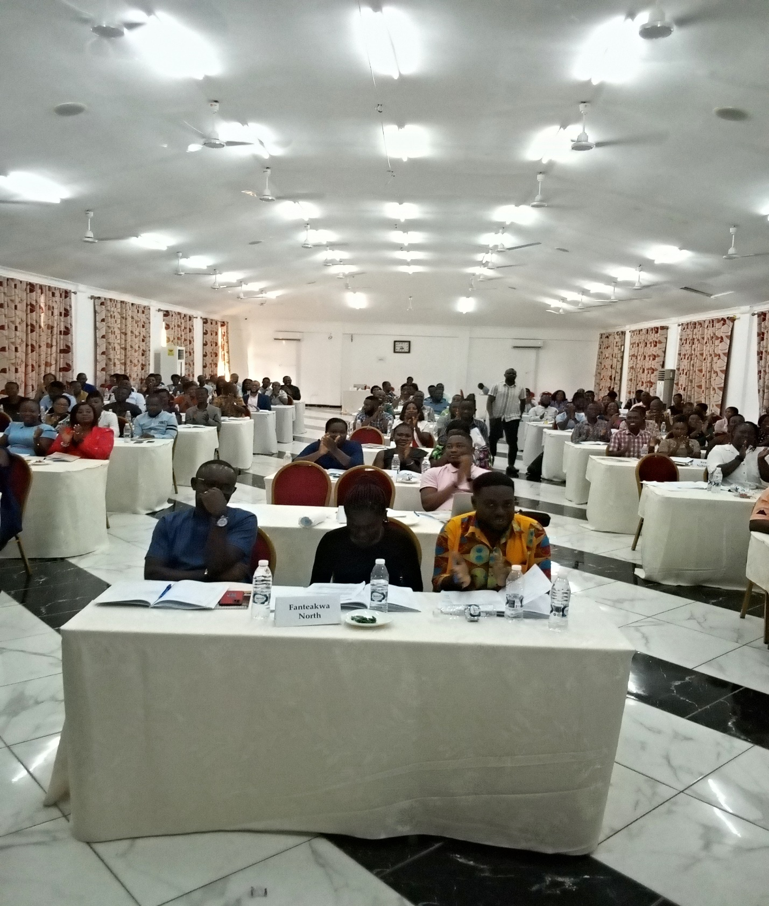
Appendix II: A Session of Participants From the various MMDAs

8.0 Questions session:
At the end of each of the training session, participants asked questions and sought clarification in respect of existing practices in the Client Service Unit of the various Assemblies.

9.0 Location (Place of training, Workshop)
The organization and delivery of the training was at the Sky Plus Hotel & Resort in Ho. The training was coordinated by Engineer Baah and other presenters from the Office of the Head of the Local Government Service (OHLGS). The venue was spacious and appropriate for the training.

10.0 Dates and time / period of the training,
The training was done in a Two-Day and scheduled as follows;
Table I
Date | Time | Period of training | Activities/Model | Target Group
13th November, 2023 | 8:30 am to  4:30 pm | 1 day | Registration of participants  Opening prayer  Self-Introduction  Welcome Address by VRCD  Opening remarks by Head of Service  Decentralization  Client Service Management  Operational Structure & Job Description  Electronic Complaint  Questions and answers | - Client Service Supervisors  - Client Service Officers  - MIS Officers  - Regional Trainers from the various RCCs  - Officers from the OHLGS
14th November, 2023 | :30 am to  4:45 pm | Day 2 | Registration of participants  Opening prayer  Compliance Monitoring  Procedure for handling visitors  Procedure for handling enquiries  Procedure for handling complaints  Procedure for handling feedback  Questions and answers | - Client Service Supervisors  - Client Service Officers  - MIS Officers  - Regional Trainers from the various RCCs  - Officers from OHLGS

11.0 Describe the target group/s for the training
The anticipated participants of the training programme were the Client Service Supervisors, Client Service Officers, Management Information System (MIS) Officers, the Regional Trainers from the various RCCs and the Officers from the OHLGS.

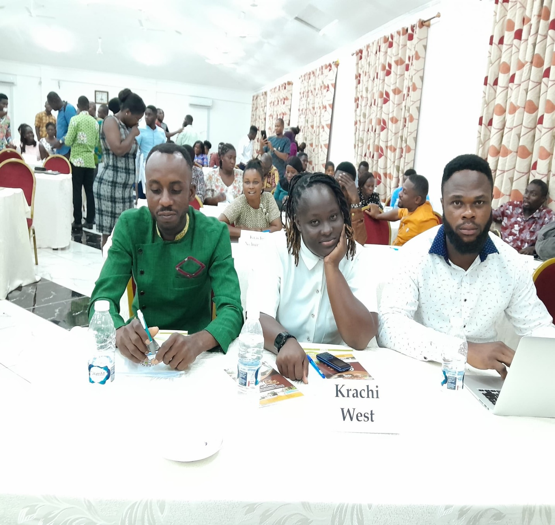
Appendix III: Participants from Krachi West Municipal Assembly

12.0 Describe the actual outcome/s of the training against the expected outcome/s
Knowledge of the targeted groups from the various MMDAs and the RCCs would have improved considerably given considerations to the good interactions, group discussions and general participation among the participants. They were also generous with information in relation to client service activities and challenges of managing client service unit, but have indicated clearly the training had now equipped them with how to do so effectively. There were lots of enthusiasm to contribute to discussions as individuals and groups. However, a post training assessment will provide further information on the extent to which the training objectives were achieved.

13.0 Provide a description of any evaluation activities undertaken and the conclusion
Before the start of the training, a brainstorming was conducted to evaluate participants’ knowledge by posing question and evaluating the response from participants, they were also asked to mention their expectations which determined a clear direction of the facilitation process. Moving on, participants were asked questions relating to the modules, under discussion and their responses evaluated to determine whether what was discussed was clearly understood or not. Participants were also asked to relate discussions under review to issues and procedures in their respective duties. The training was climaxed with an evaluation of the proceedings by the participants. Evaluation sheets were filled in softcopy form on anonymous basis and the outcome of respondents is attached.

Compliments and Commendations
- Compliments/Commendations
- “Educative, inspiring, good, challenging, helpful, useful, beneficial, amazing, appropriate, fruitful, interesting, insightful, exciting, satisfactory, commendable, impressive, refreshing, enlightening, an eye-opener, lively, great, informative, practicable, well planned, overdue, interactive, well-co-ordinated, in-depth, wonderful, well presented, purposeful, relevant, a reminder, down-to-earth delivery”
- “Very educative, very inspiring, very enlightening, very realistic, very effective, very successful, very interactive”

15.0 Challenges
- Duration too short”
- Frequent light off

16.0 Recommendations for future training activities
- Management should ensure the sustainability and frequency of this and similar programmes”
- “Raise duration of programme to at least three days”.
- “Programme should be more interactive; there should be more time for discussions and questions from participants.
Participants identified the following as areas they would like to receive further training in the future:
Table II

AREAS/TOPICS
- Training in sign language in order to be able to communicate effectively.
- Leadership and effective management of clients
- Negotiating and influencing skills, dealing with difficult customers/clients
- Good Human Relations
- Oratory/public communication skills, body language, etc
- Building and retaining customer confidence, exceeding customers’ expectations
- Empowerment, self-confidence, positive attitude, speed and quality
- Advanced lobbying skills, relationship between networking and customer care/service, networking and business planning
- Ethics and professionalism, customer relations, customer behaviour
- Microsoft, excel and word

17.0 Conclusion:
The workshop was concluded and closed by the Head of Service Rep, the person of Engineer Baah of Office of the Head of the Local Government Service (OHLGS), a representative from the office of the President. In his closing remarks, the Head of Service Rep extended his warmest greetings to the participants and resource persons for spending time with them during the programme. He acknowledged pleasantly the turn of events and the way the officers from the various MMDAs had participated in the training. He encouraged participants to share what they have learnt with their colleagues at work.
Furthermore, it was remarked that the group discussions have been very useful since the participants were put into groups to discuss the issues and share ideas after which the consultant guides the groups on good practice procedures. He reiterated that the training has come at the right time and the staff in particular must be up and doing so that the Assemblies and for that matter the Client Service Unit would increase productivity for development. In addition, he expressed his singular thanks to the consultancy firm (Ghana Secondary Cities Support Program-GSCSP) for their support and counts on them to continue their good works for the entire MMDAs community in Ghana. One of the participants was called upon to pray for God to guide and be merciful to the consultants and participants whilst they journey back to their homes.

Appendix I: Participants Evaluation of Workshop/Training:
Outcome of Evaluation:
An evaluation form was made available to all the participants to complete and return to the facilitator. Six areas were identified for evaluation and the following is the outcome of the evaluation. As noted previously, the training was for two days and different modules. However, the evaluation for the two days was consolidated for easier assessment. Therefore, Fifty (150) out of a registered Fifty (150) participants completed and returned their evaluation forms; names and portfolios of participants were not required for the evaluation and the outcome are summarized below.
- Has the training duration and venue been appropriate?
Insufficient  (0) | Sufficient  (0) | Good  (4) | Very Good  (4) | Excellent  (5)
0% | 0% | 100% | 45% | 5%

- Knowledge of Resource Person(s) in delivering Training Module
Insufficient  (1) | Sufficient  (2) | Good  (3) | Very Good  (4) | Excellent  (5)
0% | 10% | 20% | 80% | 40%

- Has your training gaps been filled with respect to the delivered training programme?
Insufficient  (1) | Sufficient  (2) | Good  (3) | Very Good  (4) | Excellent  (5)
1% | 60% | 39% | 44% | 6%

- On the evaluation of what could be done to improve subsequent training, the following responses were provided:
- Training to start early
- More group work
- More days for training in report writing and conflict management
- At least three day for each training
- All participants to be treated same when distributing
- Long notices for training
- In responding to the query about What changes participants hope to do with respect to the efficient running of the client service and their various offices as a result of the delivered training, participants provided wide and varied views to include:

- Coaching and mentoring to be promoted;
- Supervision;
- Queries to non-performing staff
- To Implement training outcome at work
- To change attitude towards service/work
- Team work

- Which areas would you like to be trained on in the future?
Participants identified the following as areas they would like to receive further training in the future:
See 4.4 above for tabulated details
18:0 SEX SEGREGATION:
TITLE OF TRAINING | MALE | FEMALE | TOTAL
Training in Sign Language | 59(8%) | 91(92%) | 150(100%)
Total | 59(8) | 91(92) | 150(100%)

During the period under review a total of 150 participants of which 59 were males representing 8% and 91 were female representing 91%.

LIST OF TABLES AND FIGURES
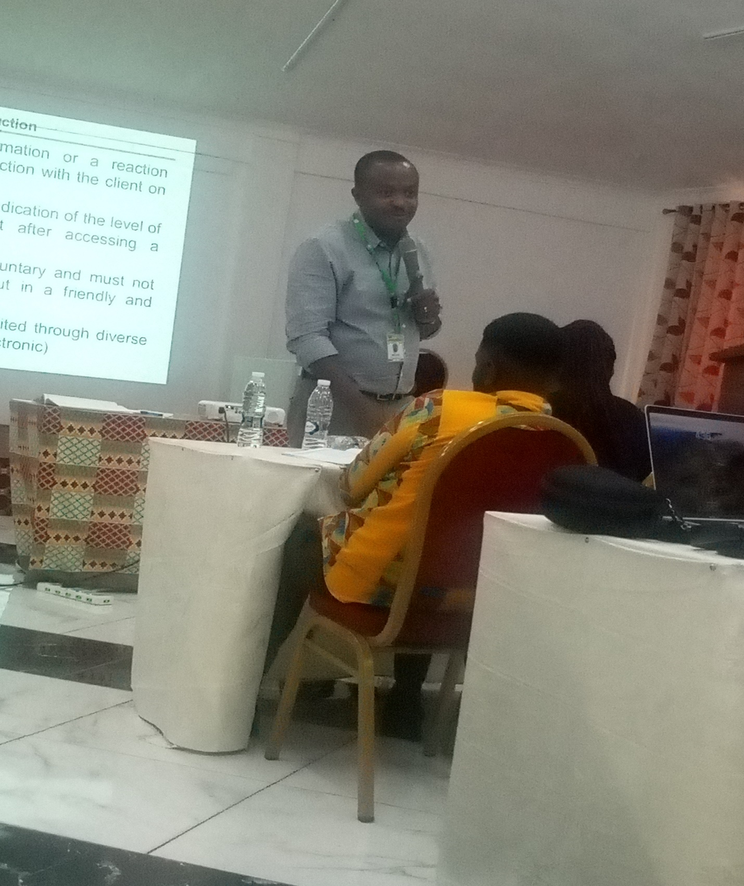
Figure I: Presentation by Engineer Baah
Appendix II: A Session of Participants From the various MMDAs

Table I
Date | Time | Period of training | Activities/Model | Target Group
13th November, 2023 | 8:30 am to  4:30 pm | 1 day | Registration of participants  Opening prayer  Self-Introduction  Welcome Address by VRCD  Opening remarks by Head of Service  Decentralization  Client Service Management  Operational Structure & Job Description  Electronic Complaint  Questions and answers | - Client Service Supervisors  - Client Service Officers  - MIS Officers  - Regional Trainers from the various RCCs  - Officers from the OHLGS
14th November, 2023 | :30 am to  4:45 pm | Day 2 | Registration of participants  Opening prayer  Compliance Monitoring  Procedure for handling visitors  Procedure for handling enquiries  Procedure for handling complaints  Procedure for handling feedback  Questions and answers | - Client Service Supervisors  - Client Service Officers  - MIS Officers  - Regional Trainers from the various RCCs  - Officers from OHLGS

Appendix III: Participants from Krachi West Municipal Assembly

Table II

AREAS/TOPICS
- Training in sign language in order to be able to communicate effectively.
- Leadership and effective management of clients
- Negotiating and influencing skills, dealing with difficult customers/clients
- Good Human Relations
- Oratory/public communication skills, body language, etc
- Building and retaining customer confidence, exceeding customers’ expectations
- Empowerment, self-confidence, positive attitude, speed and quality
- Advanced lobbying skills, relationship between networking and customer care/service, networking and business planning
- Ethics and professionalism, customer relations, customer behaviour
- Microsoft, excel and word

