
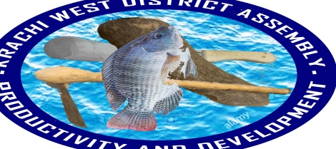
OFFICE OF THE KRACHI WEST MUNICIPAL ASSEMBLY

REPORT
ON MUNICIPAL CHIEF EXECUTIVE (DCE) ENGAGEMENT WITH

EHIAMANKYENE AREA COUNCIL & ITS SURROUNDING COMMUNITIES

ON 6TH OCTOBER, 2021

OPENING PRAYER
The meeting begins with an opening prayer By Mr. Bright Akompim, Human Resource Manager of Krachi West Municipal Assembly at exactly 10:38am for the commencement of the engagement.
INTRODUCTION OF DIGNITRIES
The Municipal Co-coordinating Director, Mr. Cletus Chevure warmly welcomes all the staff of Krachi West Municipal Assembly and representatives from the various communities in the Ehiamankyene Electoral Area. He used that platform to thank the chiefs and elders of the area and urge each and every one to feel free and participate actively.
BRIEF REMARKS BY THE MUNICIPAL CHIEF EXECUTIVE (MCE)
The Municipal Chief Executive (MCE), Hon. Emmanuel Jalulah Kajal cordially welcomed the chiefs and elders as well as the entire people of Ehiamankyene and its surrounding communities to the meeting. He went further to explain to the Chiefs and people who gathered the purpose of the engagement. The Municipal Chief Executive clearly started that, the engagement is geared towards educating the Electorates some government initiatives or projects and also take the views of participants. According to the MCE, the engagement also include updates on Covid-19 pandemic and remains ourselves the safety protocols put in place Government to arrest the effects of this deadly disease.
The MCE also expressed his sincere gratitude to the chiefs and people of the area for their support and prayers during his confirmation as the Municipal Chief Executive for Krachi West Municipal Assembly. He said, his doors are open for everyone irrespective of their position in the society. He called for a peaceful co-existence among the various tribes within the Krachi West Municipality so that the Municipality can experience the development that it deserved.
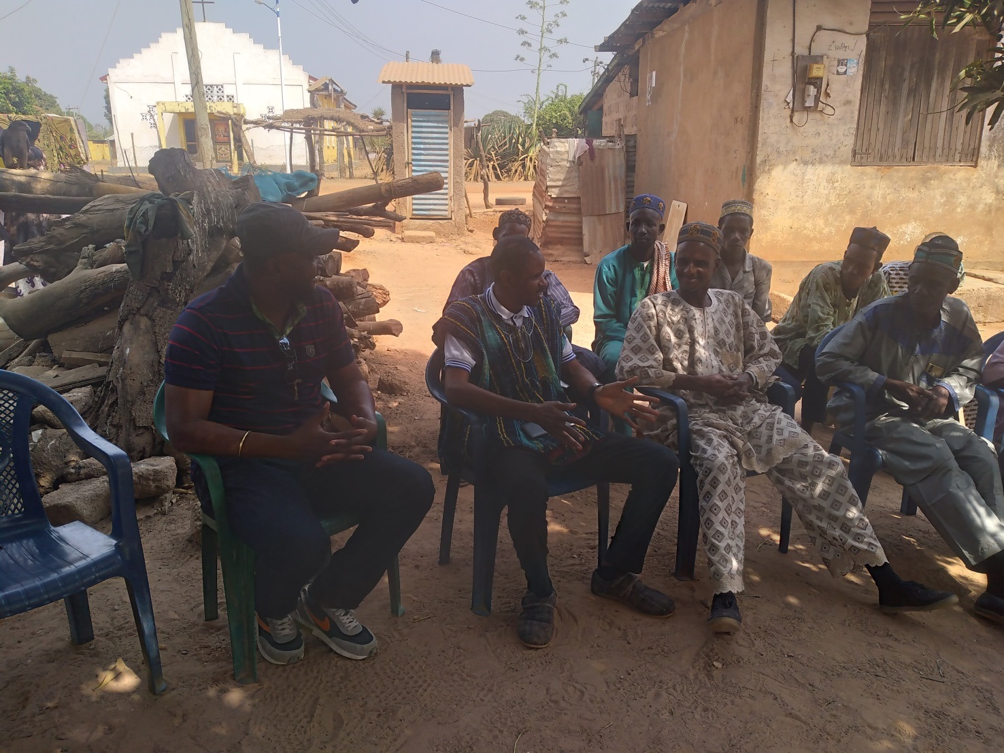
1.1 Presentation by the Hon. Municipal Chief Executive
GOVERNMENT PROJECTS AND INITIATIVES
FREE SENIOR HIGH SCHOOL
On the issue of Government Policies and Programmes, the Hon. MCE touched on a famous policies which is the Free Senior High Education. According to him, the Free Senior High School has come to stay and everybody should embrace this lucrative initiative by the Government of the day. He said, the policies do not know whether you belong to the National Democratic Congress (NDC) or the New Patriotic Party (NPP) or any of the parties in the country, hence the policy intend to increase the school enrollment at the Junior and Senior High School. The Hon. Municipal Chief Executive (MCE) said, it is always good to support any government with such initiative and contribute our quota towards the enhancement of the policy. He urged everyone to carry the message to their homes and encourage their children to take advantage of the Free Senior High School.
He made it clear to the people that, there are challenges as far as the implementation of the Free Senior High School is concern. However, measures is been put in place by government to curtail all those challenges. He said, some of the challenges are caused by us and everything depends on the way we look and embrace at the policy.

ON THE ISSUE OF PLANTING FOR FOOD AND JOBS POLICY
The presentation by the Hon. Municipal Chief Executive (MCE) also elaborated on the Planting for Food and Jobs in the Agriculture Sector. He highlighted the purpose of the initiative and why farmers have to take advantage of the policy. The MCE said, the programme is geared towards reducing the number of unemployment in the country and also change the wrong perception people have on agric. According to him, Krachi West Municipality is heavily benefiting from the Planting for Food and Jobs Policy based on the following figures or data:
Fertilizer: NPK 1000 bags of 25kg Fertilizer was distributed to 77 farmers within the Municipality
Hybrid Maize Seed: 980 bags of 45 kg Maize was also distributed to 25 farmers
OPV Seed (Local Maize) 20 bags of 45kg was distributed to 77 farmers
Agra Rice Seed (perfumed) 450 bags of 40kg to 80 farmers
Cabbage Seed (Oxylous) 240 Sachets was distributed to 46 farmers
ISSUE OF ONE DISTRICT, ONE DAM POLICY
The Municipal Chief Executive (MCE) also threw more light on the One District, One Dam policy (1D, 1D) which is concentrated in the Three Northern Regions. According the MCE, the government will priorities the programme by selecting some communities that are suitable enough to hold water throughout the year. The government realizes the difficulties that are in the northern region when it comes to water.
The Hon. MCE urge the chief and elders to embrace the initiative as this programme will go a long way to promote agricultural activities.
JICA PROJECT
JICA Project is another important initiative by the Government of the Republic of Ghana. According to him 500 women farmers across the Municipality received five (5) poultry birds (layers) each, vegetable seeds and kitchen garden net for their kitchen.
He ended his address by thanking the chief of Ehiamankyene for given him a warm welcome and urge everyone to take these policies very serious and also encourage the people to always come to the Assembly for enquiries when they do not understand something.
AGENDA 111
The Hon. Municipal Chief Executive (MCE) also throws more light on Agenda 111. According to him, the purpose of the Agenda 111 is to promote health and make it more accessible to all Ghanaians irrespective of where they are coming from. According to him, Krachi West Municipal Assembly might benefit from this initiative.
SCHOOL FEEDING PROGRAMME
The MCE also lay emphasize on the School Feeding Programme and its benefits to the development of our education sector. He said, he is very happy to announce to the gathering that, the number of schools who are benefiting from the programme has improved up to 21 schools across the Municipality. He urged Management of the programme to contribute their quota to the success of the programme as Government is doing its best to improve the standard.

CONCERNS RAISED BY THE COMMUNITY FORKS
- Mr. Kwame Nsea said, public education on radio should be intensify so that people who couldn’t attend the meeting can understand the message or policies.
- Hon. Mumuni Suraj said, the Planting for Food and Job policy is very important initiative and encourage the government to take the necessary steps to ensure a successful implementation. He urge people to remove any kind of politics when it comes to implementation of this policy.
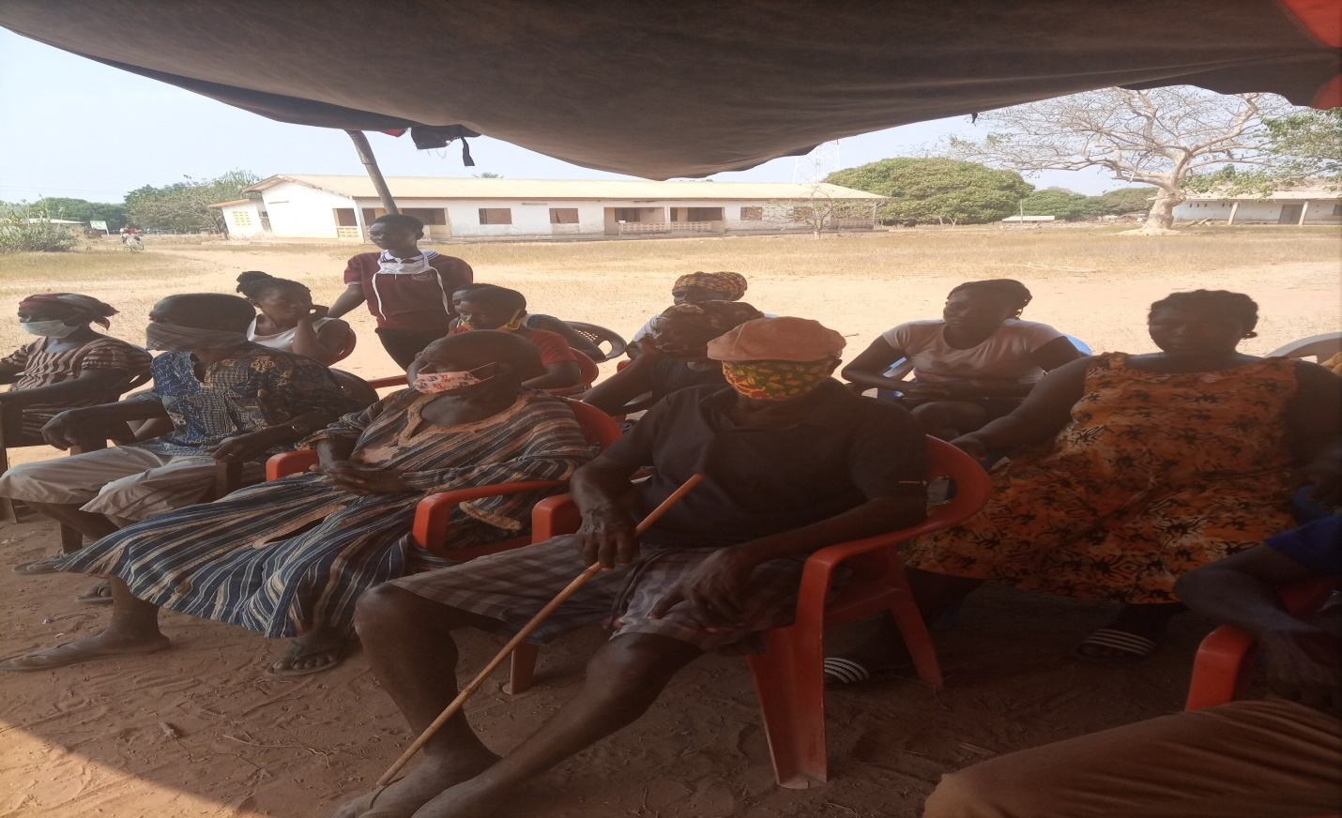

1.2 A section of Participants from the various communities
CLOSING REMARKS BY THE HON. MUNICIPAL CHIEF EXECUTIVE
The Hon. Municipal Chief Executive thanks Chiefs and Elders of Ehiamankyene for their time, energy and their wonderful contributions. He promised to work with them so that together Krachi West Municipal Assembly will receive the necessary development it deserves. He also mentioned that, all the concerns raised by people during the deliberations will be taken care off by the Assembly.
The Hon. Municipal Chief Executive ended the engagement by expressing his happiness and the reception given by the communities.
CLOSING PRAYER
The closing prayer was said by Mr. Larrey Alfred Kwame, an Assistant Director IIB of Krachi West Municipal Assembly at Exactly 2:10 pm for the adjournment of the meeting.

COMPILED BY BRIGHT AKOMPIM CHECKED BY CLETUS CHEVURE
HUMAN RESOURCE MANAGER MUN. COORD. DIRECTOR

OFFICE OF THE KRACHI WEST MUNICIPAL ASSEMBLY
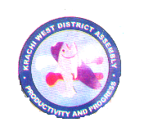

KRACHI WEST MUNICIPAL ASSEMBLY Republic of Ghana
In case of reply, the MUNICIPAL ADMINISTRATION OFFICE
number and date of this POST OFFICE BOX 1 letter should be quoted KETE-KRACHI
TEL: 0549735412/0508130396
Our Ref: KWMA/ 29th September, 2021
Your Ref…………………………………………
INVITATION TO MUNICIPAL CHIEF EXECUTIVE (MCE) ENGAGEMENT
I have been directed to cordially invite you to Municipal Chief Executive (MCE) engagement slated to come off as follows;
Date: 10th October, 2021
Time: 10:00 am Prompt
Venue: Ehiamankyene Community Center
Kindly find attached the agenda for the engagement.
Agenda:
- Opening Prayer
- Introduction of Dignitaries by the Municipal Coordinating Director (MCD)
- Brief Remarks by the Hon. Municipal Chief Executive (MCE)
- Briefing on Government Projects by MCE
- Opening Forum/Discussion
- MCE closing Remarks
CLETUS CHEVURE
(MUNICIPAL CO-ORDINATING DIRECTOR)
FOR: HON. MUNICIPAL CHIEF EXECUTIVE

Distribution
ASSEMBLYMAN OF EHIAMANKYENE ELECTORAL AREA.
CHIEFS AND REPRESENTATIVES EHIAMANKYENE
REPRESENTATIVES FROM SABAJA
REPRESENTATIVES FROM BOMMODEN
REPRESENTATIVES FROM MATALAM
REPRESNTATIVES FROMNTEWUSUAE
REP. FROM ALL SURROUNDING COMMUNITIES
ALL HEADS OF DEPARTMENTS
ALL UNIT HEADS

OFFICE OF THE KRACHI WEST DISTRICT ASSEMBLY

REPORT ON DISTRICT CHIEF EXECUTIVE (DCE) ENGAGEMENT WITH
MONKRA, KPATCHU, NTEWUSUAE AND THEIR SURROUNDING COMMUNITIES

ON 20TH MARCH, 2020

OPENING PRAYER
Opening prayer was said by Hon. Sangya Kwame Peter, the Assembly Member of Monkra Electoral Area for the commencement of the engagement at exactly 9:40 Am.
INTRODUCTION OF DIGNITRIES
The District Co-coordinating Director, Mr. Cletus Chevure welcome all the participants present and representatives from the various communities in the Monkra Electoral Area. There are about Two Hundred and Fifty participants in the meeting including Chiefs and Elders of the area. One Hundred and Five Females and One Hundred and Forty-Five Males. The DCD took his time to address all the invited gust into the community engagement.
He encourage each and every one to participate in the deliberation.
ADDRESS BY THE DISTRICT CHIEF EXECUTIVE (DCE)
The District Chief Executive (DCE), Hon. Osei-Nti Douglas welcomed the chiefs and elders as well as the entire people of Monkra/Entewusuae to the meeting. The DCE clearly started that, the engagement is geared towards educating the Electorates some government initiatives or projects and also take the views of participants. He also said, the engagement also include updates on Covid-19 pandemic and remains ourselves the safety protocols put in place Government to arrest the effects of this deadly disease.
The DCE also expressed his sincere gratitude to the chiefs and people of the area for a successful referendum which took place on 17th December, 2019.
- FREE SENIOR HIGH SCHOOL INITIATIVE
The Hon. DCE touched on a famous policies which Free Education. He said, the Free Senior High School has come to stay and everybody should embrace this lucrative initiative by the Government of the day. The Hon. DCE said, it is always good to support any government with such initiative and contribute our quota towards the enhancement of the policy. He urged everyone in Monkra to carry the message to their homes and encourage their children to take advantage of the Free Senior High School.
He made it clear to the people that, there are challenges as far as the implementation of the Free Senior High School is concern. However, measures is been put in place by government to curtail all those challenges.
- PLANTING FOR FOOD AND JOB
On the issue of Planting for Food and Jobs Policy, the presentation by the Hon. DCE also elaborated on the Planting for Food and Jobs in the Agriculture Sector. He highlighted the purpose of the initiative and why farmers have to take advantage of the policy. The DCE said, the programme is geared towards reducing the number of unemployment in the country and also change the wrong perception people have on agric.

- ONE DISTRICT, ONE DAM POLICY
The District Chief Executive also threw more light on the One District, One Dam policy which is concentrated in the Three Northern Regions. According the DCE, the government will priorities the programme by selecting some communities that are suitable enough to hold water throughout the year. The government realize the difficulties that are in the northern region when it comes to water.
The Hon. DCE urge the chief and elders to embrace the initiative as this programme will go a long way to promote agricultural activities within Monkra, Kpatchu, Ntewusuae as well as the whole country at large.
He ended his address by thanking the chief of Monkra/Ntewusuae for given him a warm welcome and urge everyone to observe all the Covid-19 safety protocols. He encourage participants to always wash their hands and wear their face masks when going out. The DCE also urge them to sanitize always.
PRESENTATION BY A REPRESENTATIVE FROM KRACHI HEALTH DIRECTORATE
A representative from Krachi Health Directorate update the gathering on Covid-19 Pandemic and urge encourage the people to observe the safety protocols. According to him, the following safety protocols should be observe;
- Always wear nose marks at any public place
- Wash your hand under running water
- Stay at home
CONCERNS RAISED BY THE COMMUNITY MEMBERS
- Hon. Sangya Peter said, he had observed that most students within the area are not observing the safety protocols. According to him, the entire problem is cause by lack of nose masks and he urged the DCE to take the necessary action.
- Mrs. Owusua Patience is also of the view that, the planting for food and Jobs should not be partisan as this will discourage citizens from embracing the policy. She said, they are all happy to have such initiative and it is the joy of every farmer.
- On the issue of Free Senior High School, Mr. Samuel Ampong expressed his joy about such an initiative but his problem is the implementation. He said, the Double Track is a headache to many and he encourage government to put proper steps in place to arrest the problem.

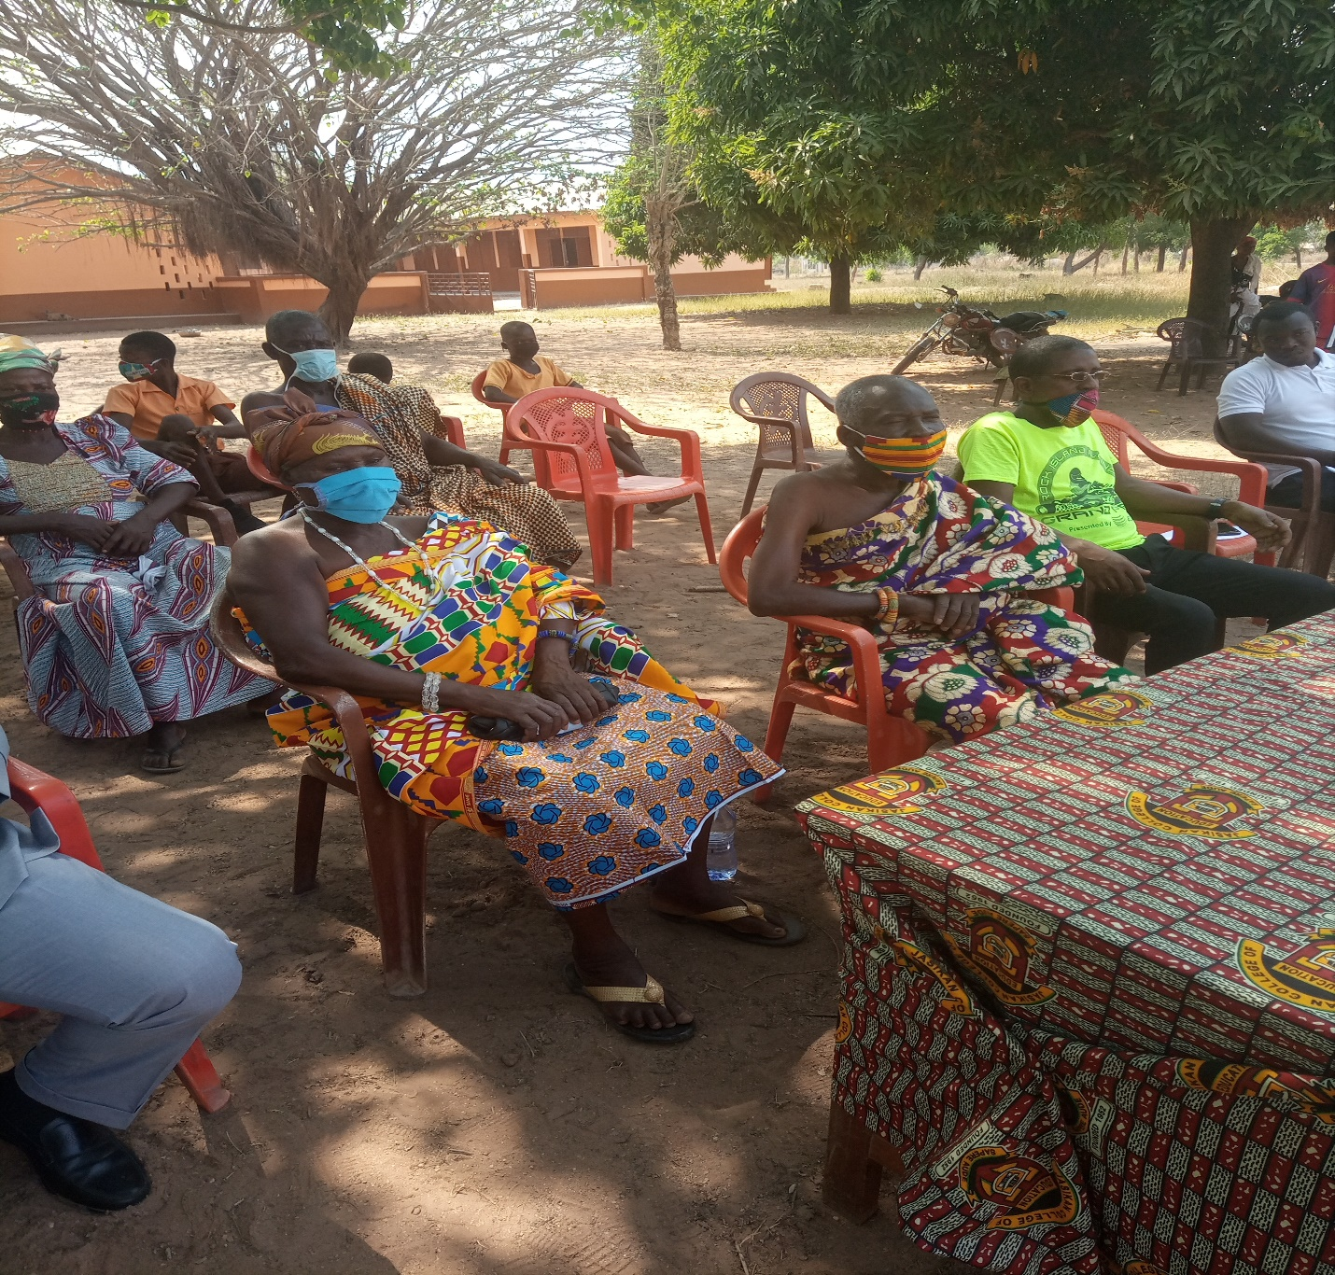
A Section of Community Members at the Engagement
DISTRICT CHIEF EXECUTIVE’S CLOSING REMARKS
The District Chief Executive, Hon. Osei-Nti Douglas thanked the Chiefs and Elders as well as the representatives of the communities for their kind gesture and the exceptional reception given. He also said, the community engagement is a periodic activities taken to explain certain initiatives and know the problems facing the various communities within Krachi West.

CLOSING PRAYER
The closing prayer was said by Hon. Sangya Peter at Exactly 1:03Pm.

PREPARED BY BRIGHT AKOMPIM COMPILED BY CLETUS CHEVURE
HUMAN RESOURCE MANAGER DIST. COORDINATING DIRECTOR
KRACHI WEST DISTRICT ASSEMBLY KRACHI WEST DIST. ASSEMBLY

OFFICE OF THE KRACHI WEST DISTRICT ASSEMBLY

KRACHIWEST DISTRICTICT ASSEMBLY Republic of Ghana
In case of reply, the DISTRICT ADMINISTRATION OFFICE
number and date of this POST OFFICE BOX 1 letter should be quoted KETE-KRACHI
TEL: 0549735412/0508130396
Our Ref: KWDA/ 10th March, 2020
Your Ref…………………………………………
INVITATION TO DISTRICT CHIEF EXECUTIVE (DCE) ENGAGEMENT
We have been directed to cordially invite you to District Chief Executive (DCE) engagement slated to come off as follows;
Date: 20th March, 2020
Time: 10:30 am Prompt
Venue: Monkra DA Primary School
Kindly find attached the agenda for the engagement.
Agenda:
- Opening Prayer
- Welcome Address by the District Coordinating Director (DCD)
- Brief Remarks by the Hon. District Chief Executive (DCE)
- Presentation by the District Director of Health
- Opening Forum
- DCE closing Remarks
CLETUS CHEVURE
(DISTRICT CO-ORDINATING DIRECTOR)
FOR: HON. DISTRICT CHIEF EXECUTIVE
Distribution
CHIEFS OF MONKRA
CHIEF OF NTEWUSAE
CHIEF OF KPATCHU
ODIKRO OF MONKRA
ODIKRO OF NTEWUSUAE
ODIKRO OF KPACHU
REPRESENTATIVES FROM ADOMAE
REPRESENTATIVES FROM OLD OSRAMANAE
TWERESO
ALL HEADS OF DEPARTMENTS
ALL UNIT HEADS
DISTRICT DIRECTOR OF HEALTH

OFFICE OF THE KRACHI WEST DISTRICT ASSEMBLY

REPORT ON DISTRICT CHIEF EXECUTIVE (DCE) ENGAGEMENT WITH
KETE-AREA COUNCIL (CHIEFS, ASSEMBLY MEMBERS, PARENTS, TEACHERS AND STUDENTS)

ON 17TH DECEMBER, 2020

OPENING PRAYER
The engagement started at exactly 8:30 am with an opening prayer by Hon. Odenke, an Assembly Member of Kantenkofri Electoral Area at Bunda School Compound.
INTRODUCTION OF DIGNITRIES
The District Co-coordinating Director, Mr. Cletus Chevure welcome teachers and students from the various schools to this august engagement. He also welcome all the invited guests who are present at that moment. He highlighted the purpose of the engagement and that is to welcome all students and teachers back to school. He encourage each and everybody to participate in the deliberation.
ADDRESS BY THE DISTRICT CHIEF EXECUTIVE (DCE)
The District Chief Executive (DCE), Hon. Osei-Nti Douglas welcomed the entire student body and teachers from the various schools back to school. He said, it is a great honour to have everybody back. The DCE clearly started that, the engagement is geared towards welcoming all students and teachers back to school and measures to put in place to prevent the spread of Covid-19 Pandemic. He highlighred the effect of the Covid-19 on economic activities and schools.
The DCE also expressed his sincere gratitude the students and teachers of the various schools for adhering to the safety protocols whiles at home.
DISTRIBUTION OF NOSE MASKS AND SANITIZERS
The Hon. DCE commended the government for early intervention during this hard time. That is, provision of food for people at their door steps, distribution of nose masks and Adonko Hand sanitizer to the various public and private institutions.
He said, the Assembly is here in collaboration with GES, Krachi West to District to distribute Nose Masks, Hand Sanitizers, PPE’s to Schools towards the fight against the pandemic. The DCE said, the fight against the coronavirus should be left in the hand of the government alone. He said, it required a collective efforts.

- PRESENTATION BY THE DISTRICT EDUCATION DIRECTOR
The Krachi West Education Director thank the Hon. District Chief Executive for his support throughout the fight against the Pandemic. She also welcome teachers and students within Krachi into the meeting. She went further to encourage teachers and students to adhere to the safety protocols since that is the only means to fight this deadly disease. The Director said, Covid-19 is real and it does not have respect for any one. She encourage students and teachers to make good use of the PPE’s and Nose Masks provide by the government as they waiting for more supports.
She used that platform to expressed her appreciations to the Muslem Community for the supporting the Directorate with Nose Masks and Hand Sanitizers.
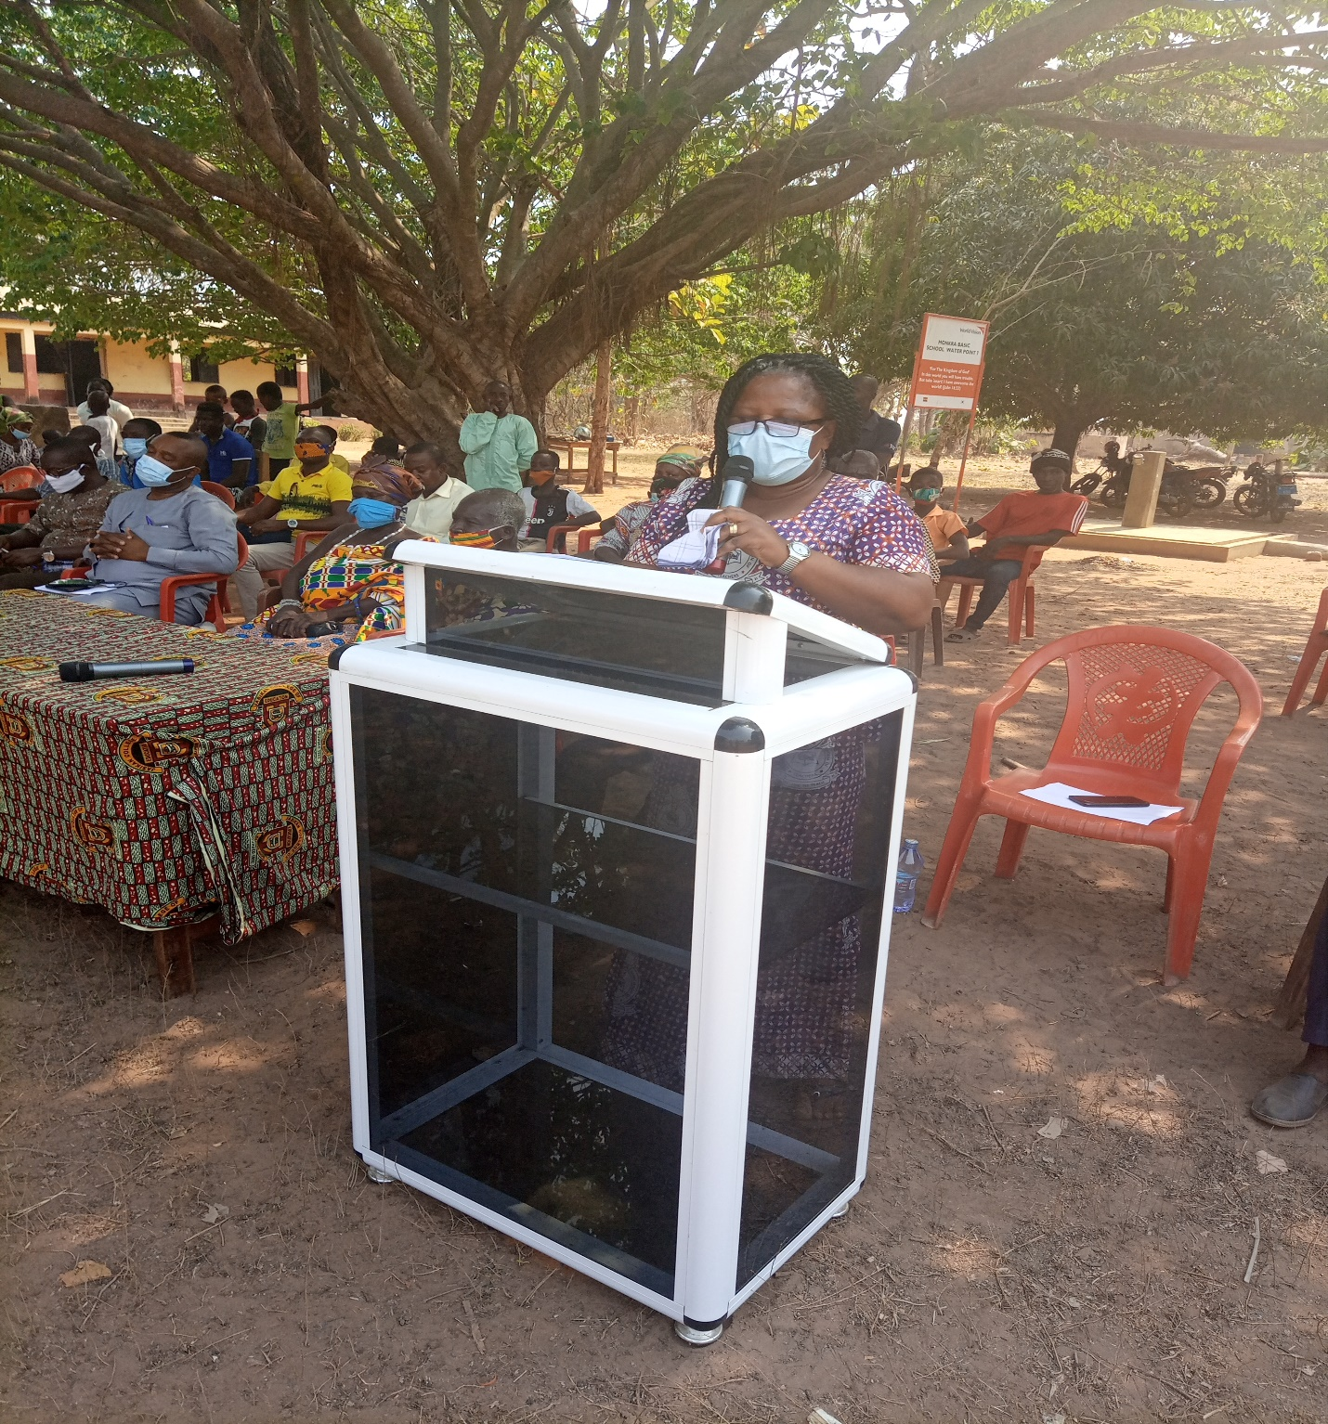
Presentation by the District Director of Education
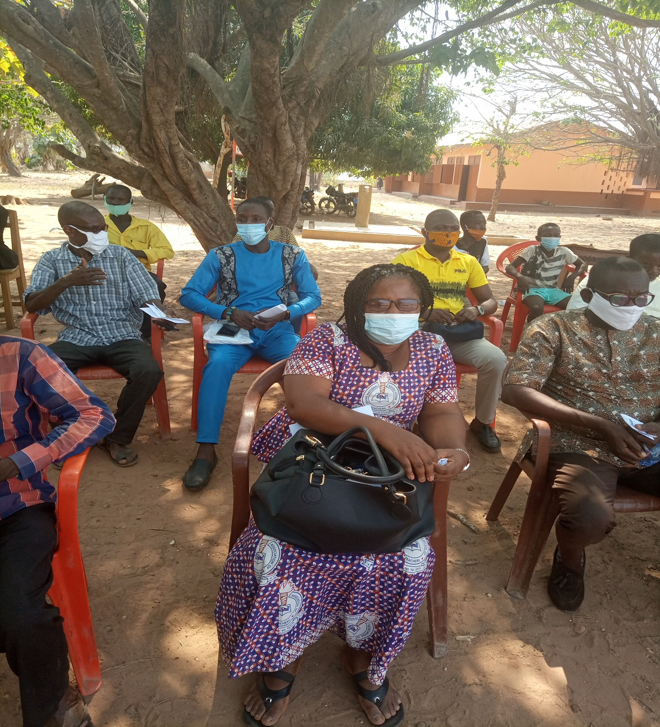
Representatives from Ghana Education Service
- BRIEF PRESENTATION BY THE DISTRICT DIRECTOR OF HEALTH
The District Director of Health expressed his appreciation to the DCE and DDE for their wonderful presentation. He updated the gathering District, Regional and National Covid-19 cases and it is enjoy to hear that Krachi West has nose case. However, he encourage the people to continue to obey the safety protocols so as to avoid the Covid-19. He said, the Hospital will do their possible best to continue to update the people any new development.

According to him, the following safety protocols should be observe;
- Always wear nose marks at any public place
- Wash your hand under running water
- Stay at home

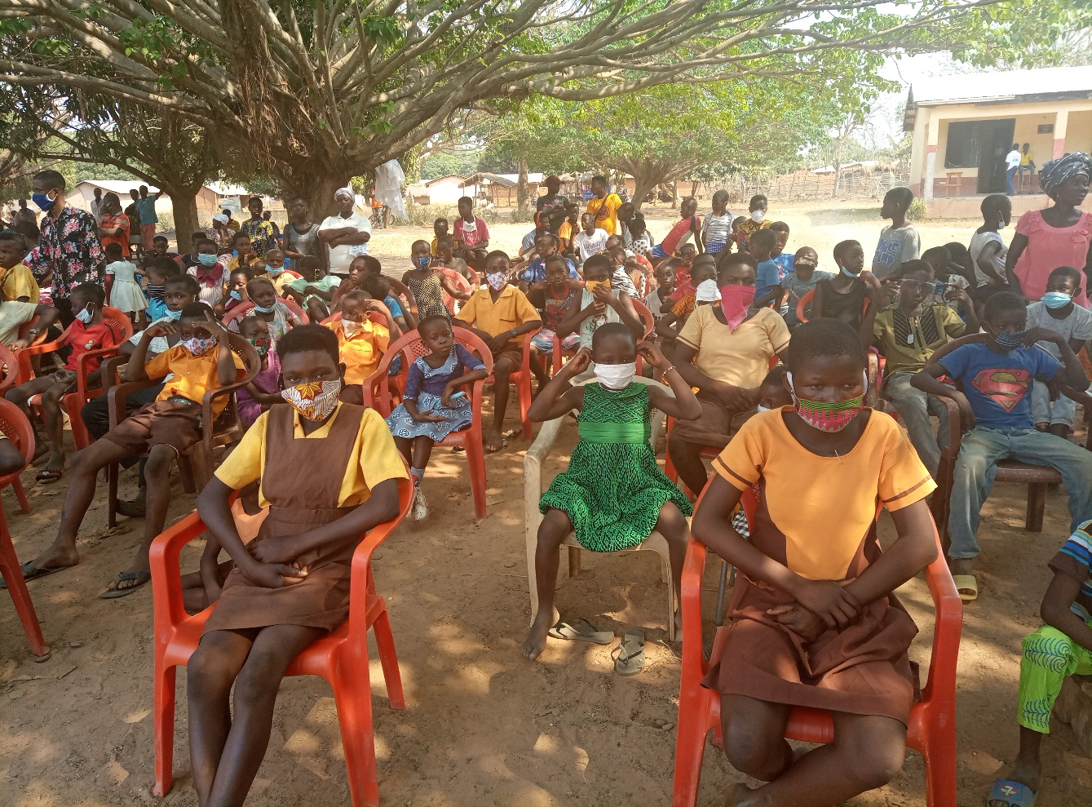
Students from the various schools
CONCERNS RAISED BY THE COMMUNITY MEMBERS
- Mr. Eliklim said, he went to encourage everybody to adhere to the safety protocols.
- Mr. Frank Dapaah also expressed his gratitude about the PPE’s. He thank the DCE and the District Assembly for their effort towards the Development of Krachi West District Assembly.

DISTRICT CHIEF EXECUTIVE’S CLOSING REMARKS
The District Chief Executive, Hon. Osei-Nti Douglas thanked the Teachers and students and urge them to follow the protocols.

CLOSING PRAYER
The closing prayer was said by Mr. Alhassan Sani at Exactly 12:21Pm.

PREPARED BY BRIGHT AKOMPIM COMPILED BY CLETUS CHEVURE
HUMAN RESOURCE MANAGER DIST. COORDINATING DIRECTOR
KRACHI WEST DISTRICT ASSEMBLY KRACHI WEST DIST. ASSEMBLY

OFFICE OF THE KRACHI WEST DISTRICT ASSEMBLY

KRACHIWEST DISTRICTICT ASSEMBLY Republic of Ghana
In case of reply, the DISTRICT ADMINISTRATION OFFICE
number and date of this POST OFFICE BOX 1 letter should be quoted KETE-KRACHI
TEL: 0549735412/0508130396
Our Ref: KWDA/ 10th December, 2020
Your Ref…………………………………………
INVITATION TO DISTRICT CHIEF EXECUTIVE (DCE) ENGAGEMENT
We have been directed to cordially invite you to District Chief Executive (DCE) engagement slated to come off as follows;
Date: 17th December, 2020
Time: 10:30 am Prompt
Venue: Henkel Park
Kindly find attached the agenda for the engagement.
Agenda:
- Opening Prayer
- Welcome Address by the District Coordinating Director (DCD)
- Brief Remarks by the Hon. District Chief Executive (DCE)
- Presentation by the District Director of Education
- Presentation by the District Director of Health
- Opening Forum/Contributions/Comments
- DCE closing Remarks

CLETUS CHIEF EXECUTIVE
(DISTRICT CO-ORDINATING DIRECTOR)
FOR: HON. DOUGLAS OSEI-NTI
Distribution
CHIEFS AND ELDERS WITHIN KETE AREA COUNCIL
ALL HEADMASTERS OF THE FIRST CYCLE INSTITUTIONS
PTA CHAIRMAN’S
ALL HEADS OF DEPARTMENTS UNITS
DISTRICT DIRECTOR OF EDUCATION
DISTRICT DIRECTOR OF HEALTH

OFFICE OF THE KRACHI WEST DISTRICT ASSEMBLY

REPORT ON DISTRICT CHIEF EXECUTIVE (DCE) ENGAGEMENT WITH
OSRAMANAE AREA COUNCIL (OSRAMANAE, MATAMALAM, MONKRA, NTEWUSAE, KPATCHU, CHANTAI, BOMMODEN, YENBRA)

ON 20TH FEBRUARY, 2020

OPENING PRAYER
The opening prayer was said by the Odikro of Osramanae for the commencement of the meeting at exactly 10:20am.
INTRODUCTION OF DIGNITRIES
The District Co-coordinating Director, Mr. Cletus Chevure warmly welcome all the staff of Krachi West District Assembly and representatives from the various communities in the Osramanae Area Council. He had expressed his gratitude to the chiefs and elders from the various communities.
BRIEF REMARKS BY THE DISTRICT CHIEF EXECUTIVE (DCE)
The District Chief Executive (DCE), Hon. Osei-Nti welcome the chiefs, elders and the entire people from the various communities to the engagement. The DCE also expressed his sincere gratitude to the chiefs and people of the area for a successful referendum which took place on 17th December, 2019. He went further to advice participants to adhere to the Covid-19 Safety Protocols. That is, wearing of nose masks, stay at home, wash your hand with soup and always report to the hospital when one experience any of the symptoms.
The Hon. District Chief Executive highlighted the purpose of the meeting. According to him, the purpose of the engagement is to educate the varius communities within the Osramanae Area Council on Government Policies and programmes and also to take grivances from the communities for further actions.
- Enforcement of the Covid-19 Safety Protocols and Distribution of PPE’s
The District Chief Executive (DCE) went further to talk about the increasing rate of Covid-19 cases in the District and the Government effort in the fight against the Covid-19 virus. He said, the Government has given the District quit number of PPE’s and Sanitizers to be distribute to Schools and other public and private institutions within the District. He encourage all to continue to adhere to the Covid-19 Protocols.
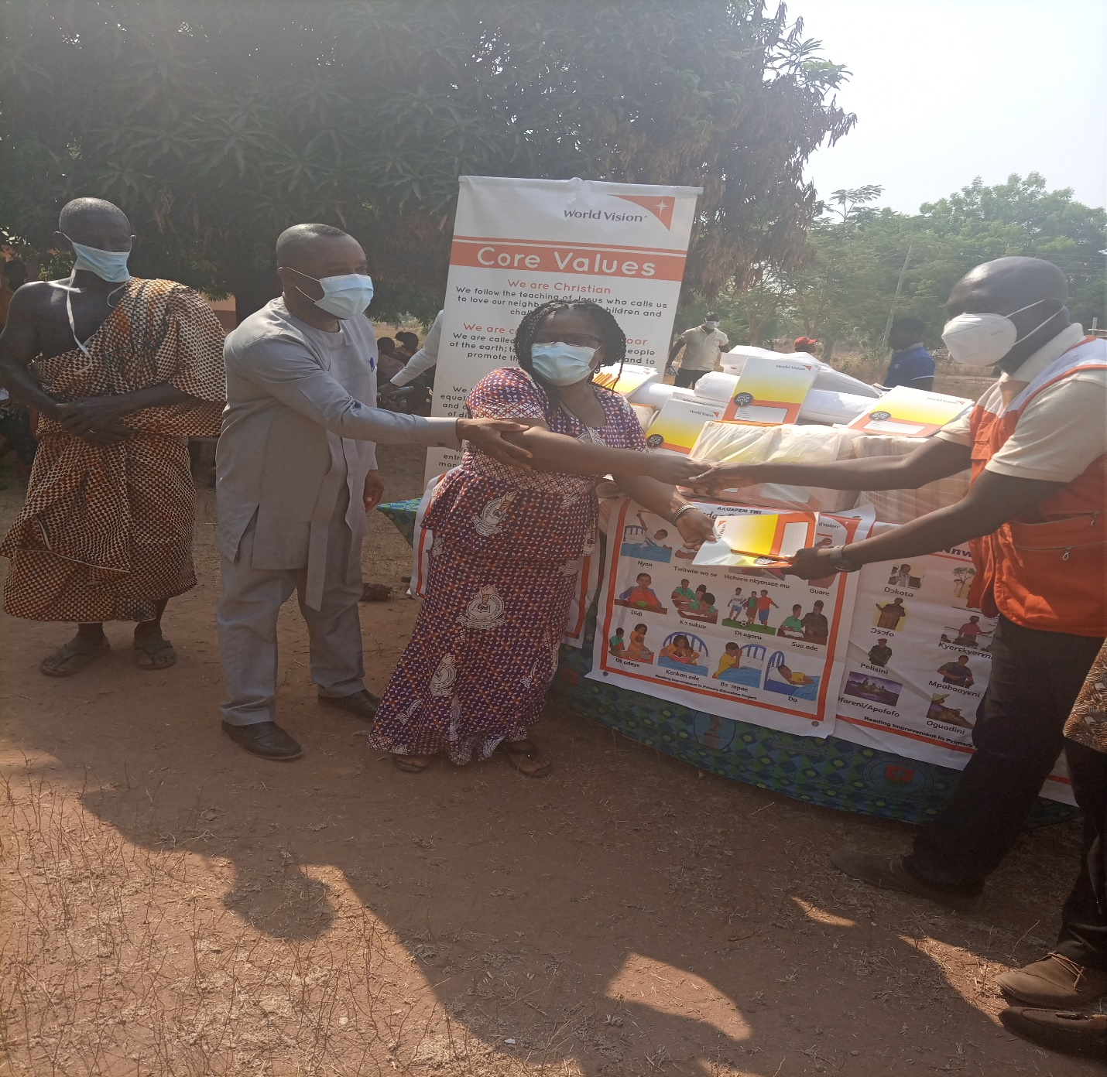
Distribution of PPE’s
- Rural Electrification Project
The Hon. District Chief Executive also talk about the ongoing Rural Electrification Project going on the District. He had expressed his joy about the way the projects are progressing and urged the entire people people to embrace the programme as it intent to solve electricity problem in the District. He said, the programme has covered a lot of communities in the District especially, the Islands communities.
- Fulani Menace in the District
The Hon. District Chief Executive had expressed his grieve and worry about the complains and agitation from some of the farmers within the District. According him, quit number of farmers reported to him about the behaviors of cattle owners and the fulani’s within the District. That is, how cattle graze on their farmlands and destroyed crops.
He said, the Assembly has putting measures in place to resolve this canker and very soon this problem will be resolve. He said, registration of Fulanis’ in the District is very important as this will go a long way to help trace them whenever they engage in any bad act.

CONCERNS RAISED BY THE COMMUNITY MEMBERS
- Mr. Dzatake said, there is no access to electricity in some communities. They will appreciate it if they could be considered for a solar grid similar to the one being constructed at Aglakope.
Response: The Hon. DCE informed all the participants that the project at Aglakope was a pilot project. He said, the Rural Electrification will soon solve this problem.
- Mr. Ntumi Stephen. According to him, poor network coverage in the communities is a major problem. This make communication very difficult and also affect business activities in the area.
Community members were informed that the Ghana Investment Fund for Electronic Communications (GIFEC) to see how they can help put up mini cell sities in the District to improve network coverage
- Destruction of Farm Lands by Cattle: Mr. Kumah made mentioned of how cattle continue to destroy farm lands in the District.
Response: Hon. DCE informed the community members that he was going to ensure that all cattle owners and headsmen are registered in the District and subsequently invited to DISEC for discussion on how to resolve this challenge.

Other Matters
- Frequent shortage of premix fuel in the community hampering the progress of their economic activities and mobility as water transport was their main mode of transport.
According to the Hon. DCE, landing beach were established in order to ensure a fair distribution of the premix.
- By Nana Attah-Kpebu: He expressed his excitement about the action of the Assembly. He urged the Hon. District Chief Executive and the District Assembly as a whole to ensure that, most of the items in the Annual Budget should be implemented.

CLOSING REMARKS BY THE HON. DISTRICT CHIEF EXECUTIVE
The Hon. District Chief Executive ended the engagement by expressing his happiness and the reception given by the communities. He promised the people that all their concerns is well taken and implantation will start as soon as possible to ensure the development of the District and the country at large.
CLOSING PRAYER
The closing prayer was said by Mr. Akan-urge Abugre, The District Planning Officer Krachi West District Assembly at Exactly 2:57 pm.

PREPARED BY BRIGHT AKOMPIM COMPILED BY CLETUS CHEVURE
HUMAN RESOURCE MANAGER DIST. COORD. DIRECTOR

OFFICE OF THE KRACHI WEST DISTRICT ASSEMBLY

KRACHIWEST DISTRICTICT ASSEMBLY Republic of Ghana
In case of reply, the DISTRICT ADMINISTRATION OFFICE
number and date of this POST OFFICE BOX 1 letter should be quoted KETE-KRACHI
TEL: 0549735412/0508130396
Our Ref: KWDA/ 13th February, 2020
Your Ref…………………………………………
INVITATION TO DISTRICT CHIEF EXECUTIVE (DCE) ENGAGEMENT WITH OSRAMANAE AREA COUNCIL
We have been directed to cordially invite you to District Chief Executive (DCE) engagement slated to come off as follows;
Date: 20th February, 2020
Time: 10:00 am Prompt
Venue: Osramanae Community Center
Kindly find attached the agenda for the engagement.
Agenda:
- Opening Prayer
- Roll Call
- Welcome Address by the District Coordinating Director (DCD)
- Brief Remarks by the Hon. District Chief Executive (DCE)
- Opening Forum/Contributions/Comments
- DCE closing Remarks

CLETUS CHEVURE
(DISTRICT CO-ORDINATING DIRECTOR)
FOR: HON. DISTRICT CHIEF EXECUTIVE
Distribution
- All Assembly Members within Osramanae Area Council
- All Adikrofo within Osramanae Area Council
- Chief and Elders of Osramanae Area Council
- All Unit Committee Members
- All Heads of Departments and Units

REPORT ON DISTRICT CHIEF EXECUTIVE ENGAGEMENT WITH CHIEFS, FULANI HERDSMEN, CATTLE OWNERS AND SAND WINNERS, HELD ON 29TH MAY, 2020 AT VARIOUS COMMUNITIES WITHIN KRACHI WEST DISTRICT
ATTENDANCE
S/N | NAME | DESIGNATION/COMMUNITY
1 | HON. DOUGLAS OSEI-NTI | HON. DCE
2 | CLETUS CHEVURE | DCD
3 | JOSEPH BOATENG | ADIIB
4 | BRIGHT AKOMPIM | HRM
5 | NANA ATTAH KPEBA | GYENGYEN
6 | ADDAE DANIEL | MONKRA
7 | ANTHONY MENSAH | BOMMODEN
8 | DONKOR KWAKU BOB | TANTU
9 | HON. OBIMPEH ALBERT | ASSEMBLY MEMBER
10 | HON. SANGYA PETER KWAME | ASSEMBLY MEMBER
11 | GYAME KWAME | ODIKRO
12 | HUCASH MUNTARI | ASSEMBLY MEMBER-SOLDIER CAMP
13 | JOHN BOATENG ADDAE | AG. OTI REGIONAL HEAD EPA
14 | HON. ALI KWEBLA | ASSEMBLY MEMBER-SOFOLIN
15 | MUMUNI SARAY | EHIAMANKYENE
16 | OSEI-BONSU W. | KETE-KRACHI
17 | EMMANUEL OWUSU | KRACHI
18 | KOFI-OWUSU | KRACHI
19 | ABABIO YAW KUMAH | KRACHI
20 | OWUSU KING JOJO | KRACHI
21 | BOBSON ADAWOBOSON | DEHO
22 | JOHN NUMEKPEKU | DWE

ITEMS | SUBJECT | ACTION BY
1.0 | - OPENING  The opening prayer was said by Joseph Boateng ADIIA at 11:50am for the commencement of the meeting.  - BRIEF REMARKS BY THE HON. DCE  The DCE welcomed all members present at the meeting and apologized for coming in late. He began by highlighting the purpose of the meeting. He said that, the purpose of this meeting is to discuss the manner in which Sand Winners fetched sand in the district. That is, their activities can cause land degradation if proper measures are not taken to combat it. According to the Hon. DCE, sand winning is the process of taking sand from one place to another for the purpose of construction or building. Sand winning form part of mining according to the constitution of Ghana.  We are here to discuss the proper measures to follow in sand winning or fetching sand. There is an observation that, people are fetching sand indiscriminately. They do not follow the right procedures in fetching sand. We are here to make bye-laws to govern the sand winning activities in the district. He went further to added that, the meeting also geared towards addressing the issues of Fulani menace in the District. That is, the confusion between Farmers and Fulanis’ in the District  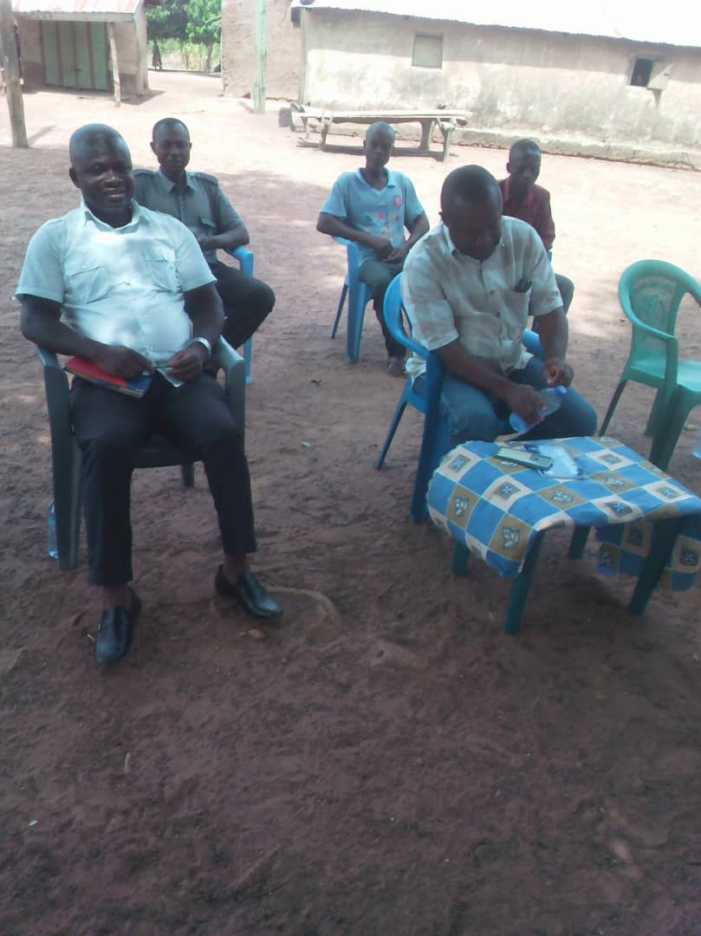  - BRIEF REMARKS FROM THE ACTING ENVIRONMENTAL PROTECTION OFFICER  According to the Minerals Commission, the sand does not belong to communities but the community has the right to process the mineral in that land. Preparation of site plans is very prominent. No one can use the minerals without going through the right procedures. He advice that, preparation of site Map and submit to Mineral Commission is very relevant.  - SUGGESTIONS  Mr. Ababio: He said, most of the Sand Winners do not know the site owners or owners of the land at Krachi West District. According to the Chief of Gyengyen Community, one must get the right of entry before doing something on the land. He also said, most of the winners are claiming that, the land belongs to VRA but he wants to let everybody know that, VRA has no land at Gyengyen. The matter need to be address by the house urgently. He also wants to tell the Sand Winners and Tipper Track owners that, they must come and site with them and if they refused to adhere to that, they should not come and fetch sand at the area.  According to the Environmental Protection Agency Officer, there is the need to seek for building permit before constructing any structure. The constitution does not permit anyone to cut-down trees or fetch sand indiscriminately. Before, you can fetch sand, you need to pass through the right procedures. That is, you need to have land entry permit, Mineral Commission and so forth.  Assembly Member, Sofoline-Is it right to fetch sand from the river bank? Some of the Sand Winners fetched sand from the river bank which endangered human life. According to the Assembly Member, he even confronted the Sand Winners and they told him that, they paid money to the Assembly and Nananom.  According to the EPA Officer, no one has the right to fetched sand in the river without putting measures in place. Those acts were illegal and need to be stopped.  A member from Tantu, people have dug sand and created a huge gutter at the community. This was very risky when rain falls or the water volume starts increasing. According to one of the native of Tantu, they used escalators to dig and used the sand for road construction.  According to the EPA officer, in response to what the member from Tantu stated, the contractor sort environmental permit before they dug. If it was a hollow pit they would cover it.  Mr. Ababio: He said, when they went to Tantu, they instructed all sand winners to fetch only from the surface and should not go deep.  According to the chief of Gyengyen, he wants Taller to tell the house why the land belongs to VRA.  Mr. Kumah Benjamin also commented on the behavior of some of the cattle owners in the District. According to him, some of the cattle owners always refused to accept the fact that their cattle has destroyed peoples farmland after the herdsmen reported.  In reponse, the Hon. District Chief Executive said, measures has been taken by the Assembly to register every Fulani Herdsman in the District for easy identification. He promised them that very soon the problem will be resolve.  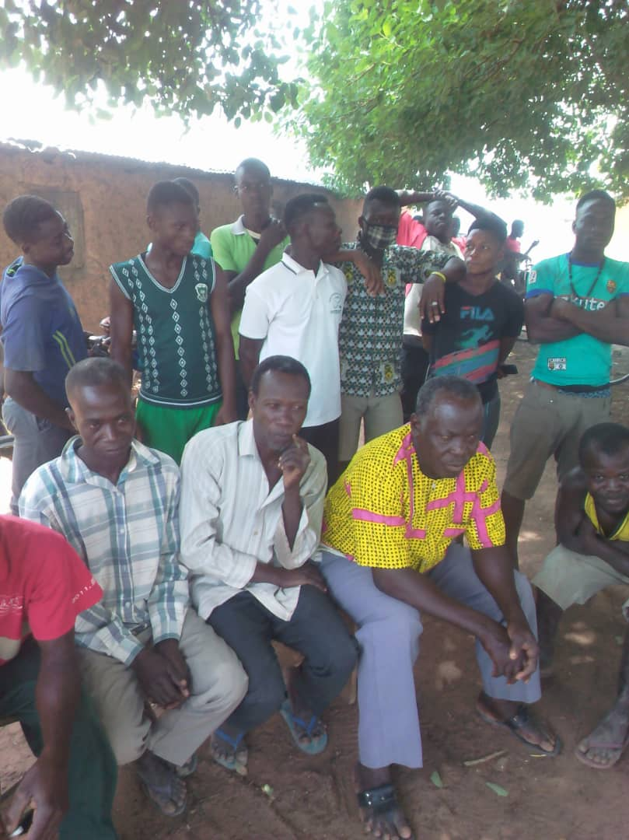  A GROUP OF PARTICIPANTS  - MEASURES TO REDUCE THE EFFECT OF SAND WINNING AT KETE-KRACHI  - The DCE should develop a Map for the entire district and the communities. (Assembly Map should be created-Krachi West District Map).  - Formation of Sand Winners Association.  - The Association should seek collectively registration of sand winning.  - The Engineer and some members of the Sand Winners will inspect the various sites where sand winners operate and report back to the Assembly. The lakeside will be inspected.  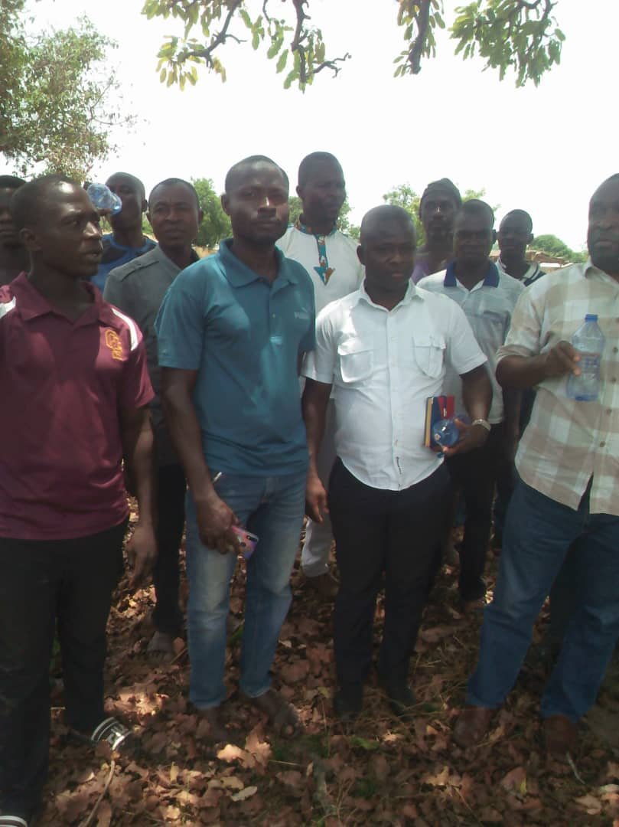  PARTICIPANTS FROM VARIOUS COMMUNITIES  - CLOSING PRAYER/ADJOURNMENT  Nana Attah Gyengyen herewith, moved the motion for the adjournment of the meeting. Closing prayer was said by Donkor Kwaku at 2:24 pm.

Compiled by Bright Akompim
(District Human Resource Manager)

OFFICE OF THE KRACHI WEST DISTRICT ASSEMBLY

KRACHIWEST DISTRICTICT ASSEMBLY Republic of Ghana
In case of reply, the DISTRICT ADMINISTRATION OFFICE
number and date of this POST OFFICE BOX 1 letter should be quoted KETE-KRACHI TEL:0549735412/0508130396
Our Ref: KWDA/ 20th May, 2020

INVITATION TO HON. DISTRICT CHIEF EXECUTIVE (DCE) ENGAGEMENT
You are cordially summon to a meeting with the Hon. District Chief Executive. The Purpose of the meeting is to find solution to the ever increasing havocs that sand winning and its related activities are causing to our environment as well as the Fulani Menace in the District.
The meeting is scheduled as follows;
Date: 29th May, 2020
Time: 10:00am Prompt
Venue: Osramane Community Centre
Counting on your usual cooperation.

Thank you.

CLETUS CHEVURE
(AG. DISTRICT COORD. DIRECTOR)
FOR HON. DISTRICT CHIEF EXECUTIVE

DISTRIBUTION
ALL SAND WINNERS
TIPPER TRUCK OPERATORS
All Cattle Owners
All Fulani Herdsmen in the District
ENVIRONMENTAL HEALTH OFFICER
ALL ASSEMBLY MEMBERS KRACHI TOWNSHIP
ADIKTOFO-KRACHI TRADITIONAL AREA

REPORT ON TOWN HALL MEETING HELD AT KETE AREA AND OSRAMANAE COUNCILS ON REVIEW OF THE ANNUAL BUDGET AND WORK PLANS FOR THE PREVIOUS YEAR ON 15TH FEBRUARY, 2020
1. OPENING PRAYER
The opening prayer was said by Hon. Odenken Ntim, the Assembly Member of Adankpa Electoral Area for the commencement of the meeting at exactly 10:30 am.
2. INTRODUCTION OF CHAIRMAN
The MC introduced the chairman for the occasion. He is the person of Nana Attah-Kpebu, who represent the Paramount Chief of Krachi Traditional Council, Nana Mpra Bisemuna.
3. CHAIRMAN’S ACCEPTANCE REMARKS
The Chairman welcome all the members present and expressed his joy and happiness to be present. He went further to thank all present for the recognition they accorded and selected him to chair this important occasion. He called on the co-operation from chiefs and people present.
4. INTRODUCTION OF DIGNITARIES BY THE MC
The MC used the platform to introduce all the dignitaries present. He started with the introduction of the District Chief Executive (DCE), Hon. Douglas Osei-Nti, the District Co-ordinating Director, Mr. Cletus Chevure, The Presiding Member, Heads of Departments and Units Heads, Representatives from World Vision, NADMO, Kaakyi-FM, NEDCO, and Hon. Assembly Members and so on.
5. PRESENTATION OF THE 2020 ANNUAL BUDGET AND WORK PLAN BY THE DISTRICT BUDGET ANALYST
The District Budget Analyst presented the 2020 Budget and Work Plan on behalf of the District Chief Executive. The Budget Analyst during the presentation of the budget pointed out that, the PFM Act required that a meeting like this should be held on the Annual Budget for the previous year and in the third quarter of the current year. According to him, the 2020 Budget contained important projects which geared towards the Development of the District as per the attached Budget Templates.
The Budget analyst said, the Assembly has implemented numerous projects and programmes since 2017 to date 2020 and still implementing more. Some of the projects have been completed whiles others are ongoing as per the attached pictures. He made it clear to the gathering that, some of the projects delayed because funds are not released on time.
According to him, some of the projects are not under the control of the Assembly since those projects are awarded from the Central Government and Contractors are paid at the National Level. What the Assembly do is to supervise the projects and report.
KEY ACHIEVEMENTS (2020)
The following are some of the achievement in the budget since 2019;
- Constructed A 12 Seater Toilets at the Kete-Krachi Lakeside
- Constructed A Physio-Therapy Center at Kete-Krachi District Hospital
- Constructed A CHPS Compound at Kwakuae
- Constructed KG Block at Ehiamankyene-Chorkorsi
- Converted a Market store for use as District Masloc Office
- Rehabilitated Abujuro Primary School
- Rehabilitated Abujuro KG School
- Rehabilitation of Monkra KG School
- Renovated Rural Enterprise Facility

PICTORAL EVIDENCE OF SOME PROJECTS
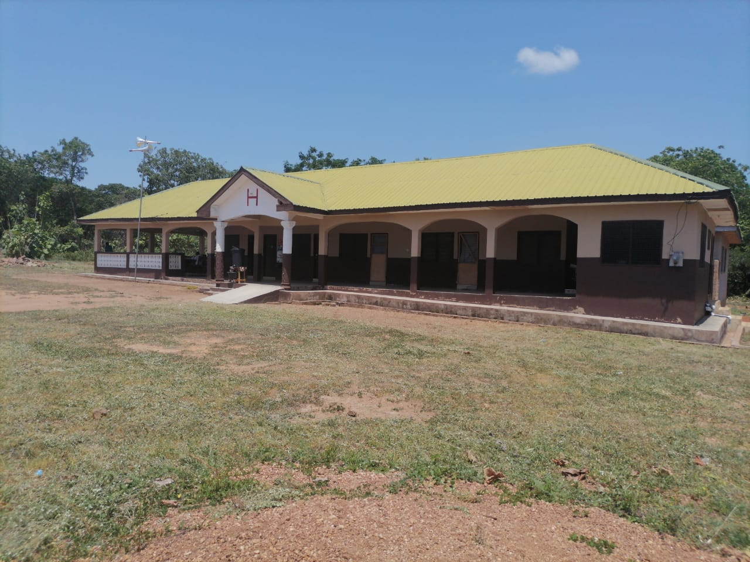
CHPS Compound at Kwakuae
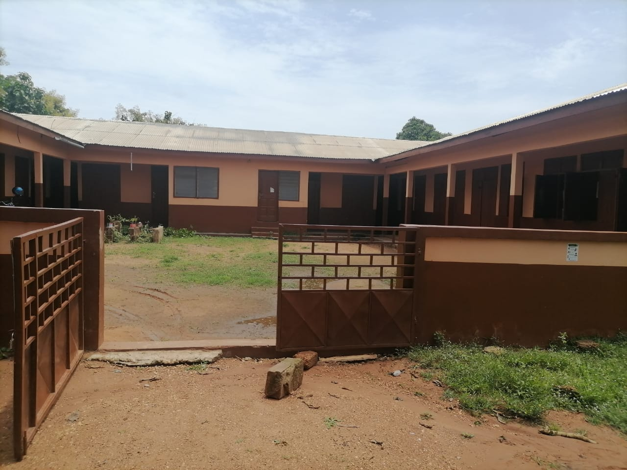
Rehabilitated Abujuro Primary School
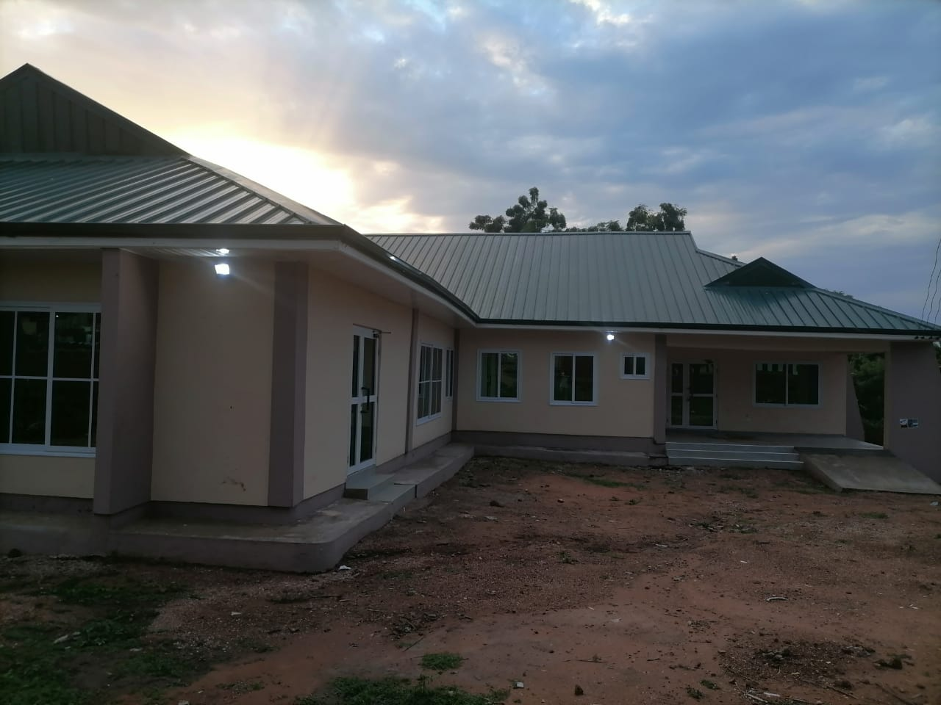
A Physio-Therapy Center at Krachi District Hospital
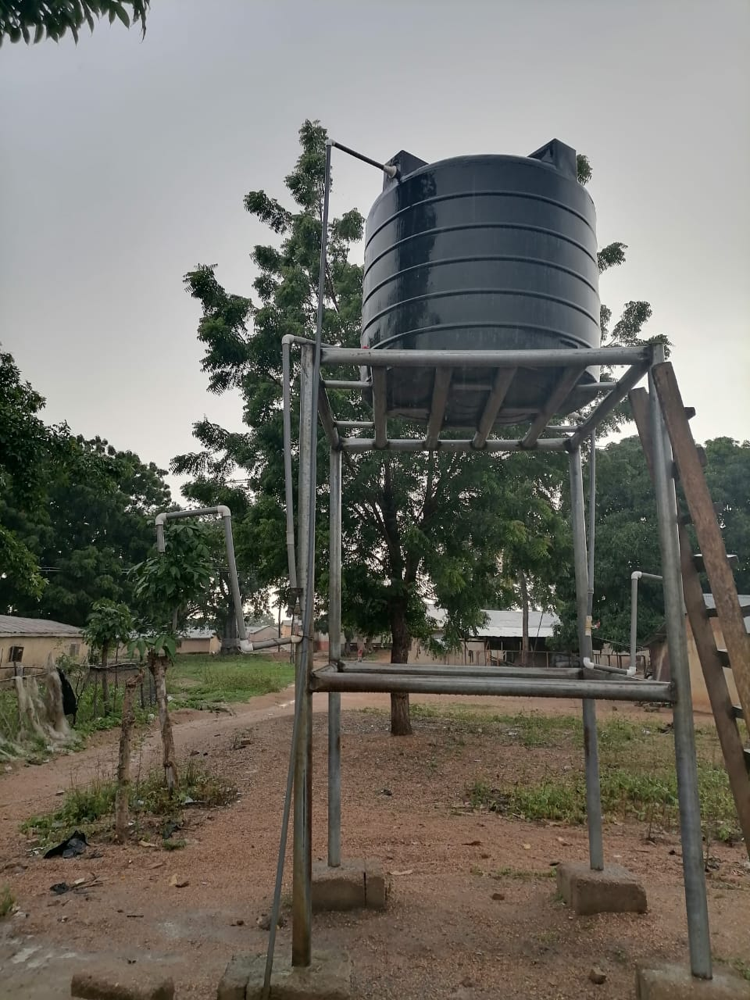
Renovated RFT Project
SOURCES OF FUNDS FOR THE ASSEMBLY
According to the District Budget Analyst, the Assembly source of funds include, Internally Generated Fund (IGF), District Assembly Common Fund (DACF), DONOR, and DDF. He concluded by expressing his appreciation to the chiefs and elders for their patience and time.
6. DISCUSSION OF THE BUDGET
- Gyengyen Chief appealed to the DCE and the Assembly to speed up their activities especially those under the direct control of the Assembly. He made mentioned of CHPS Compound to help improved the health of the people of Gyengyen and the surrounding communities. He went further to say that, they have to travel a long distance for medical attention.
- Odikro of Abujuro also mentioned of a CHPS compound to be constructed at Abujuro in order to improve the health of the people.
In response, the Hon. District Chief Executive said, most of these projects and programmes will be resolved very soon for the betterment of the people in Krachi West District.
He also went ahead to appealed to the people to vote the government of the day in power for the people to continue to enjoy these important policies and projects. He encourage the people to embrace the free education and the Planting for food and job programmes. According to him, those policies are meant to improve the livelihood of the people of Ghana and Krachi West to be specific.
7. OTHER MATTERS
Nana Atta made mention of the how cattle were allowed by Herdsmen to destroyed other peoples farm lands. He appealed to the gathering and the chiefs to advice the herdsmen at their various communities. The confusion between farmers and herdsmen/Fulani’s is very bad and does not encourage development. He noted that, it was always disappointing to observed that Fulani’s and cattle owners who were invited to deliberate on the way forward on the Fulani menace did not make attempt to attend.
8. CLOSING REMARKS BY THE HON. DISTRICT CHIEF EXECUTIVE
The Hon. District Chief Executive thank the people for their patience as this programme extend one and half hour but they were still participating actively. He also thank the chiefs and elders from the varous communities and the representative of Nana Krachi Wura. He thank the Chairman for his wonderful work and promised to execute most of the projects as indicated in the budget.
9. CLOSING PRAYER
The closing prayer was said by Mr. Boateng Joseph, Assistant Director II B at exactly 12:48 pm

PREPARED BY BRIGHT AKOMPIM COMPILED BY CLETUS CHEVURE
(HUMAN RESOURCE MANAGER) (DIST. COORD. DIRECTOR)

OFFICE OF THE KRACHI WEST DISTRICT ASSEMBLY

KRACHIWEST DISTRICTICT ASSEMBLY Republic of Ghana
In case of reply, the DISTRICT ADMINISTRATION OFFICE
number and date of this POST OFFICE BOX 1 letter should be quoted KETE-KRACHI
TEL: 0549735412/0508130396
Our Ref: KWDA/ 2nd February, 2020
Your Ref…………………………………………
INVITATION TO TOWN HALL MEETING
You are cordially invited to a Town Hall meeting schedule as follows;
Date: 15th February, 2020
Time: 10:30 am Prompt
Venue: Krachi West District Assembly Hall

Agenda:
- Opening Prayer
- Welcome Address by Chairman
- Brief Remarks by the Hon. District Chief Executive
- Presentation on the Review of the Annual Budget and Work Plans for the previous years
- Chairman’s closing Remarks
- Closing prayer.

CLETUS CHEVURE
(DISTRICT COORDINATING DIRECTOR)
FOR: HON. DISTRICT CHIEF EXECUTIVE
DISTRIBUTION
The Paramount Chief of Kete-Krachi-Nana Krachi Wura
All Sub-Chiefs and Elders
The Member of Paramount for Krachi West District
All Assembly Members within the Kete- Area Council
All Assembly Members within the Osramanae Area Council
ALL HEADS OF DEPARTMENTS AND UNITS HEADS
All Non-Governmental Organisations
Headmaster, Krachi Senior High School
Head Master, Community Technical Institute
Director, Kaakye FM
Director, Nyiwase Radio

REPORT ON TOWN HALL MEETING HELD AT KETE AND OSRAMANAE AREA COUNCILS ON THE IMPLEMENTATION OF THE ANNUAL BUDGET AND WORK PLANS ON 7TH SEPTEMBER, 2020
1. OPENING PRAYER
The opening prayer was said by Hon. Siaw Kwadwo, the Assembly Member of Osramanae Electoral Area for the commencement of the meeting at exactly 10:32 am.
2. INTRODUCTION OF DIGNITARIES BY THE MC
The MC used the platform to introduce all the dignitaries present. He started with the introduction of the Chief of Osramanae, Elders, District Chief Executive (DCE), Hon. Douglas Osei-Nti, the District Co-ordinating Director, Mr. Cletus Chevure, The Presiding Member, Heads of Departments and Units Heads, Representatives from ECG, Kaakyi-FM, NEDCO, and Hon. Assembly Members and so on.
5. PRESENTATION OF THE 2020 BUDGET IMPLEMENTATION AND WORK PLAN BY THE DISTRICT BUDGET ANALYST
The District Budget Analyst presented the 2020 Budget on behalf of the District Chief Executive. The Budget Analyst during the presentation of the budget pointed out that, the PFM Act required that a meeting like this should be held on the implementation of the budget for the previous year and in the third quarter of the current year.
Some of the projects have been completed whiles others are ongoing. He made it clear to the gathering that, some of the projects delayed because funds are not released on time.
According to him, some of the projects are not under the control of the Assembly since those projects are awarded from the Central Government and Contractors are paid at the National Level. What the Assembly do is to supervise the projects and report.

SOURCES OF FUNDS FOR THE ASSEMBLY
According to the District Budget Analyst, the Assembly source of funds include, Internally Generated Fund (IGF), District Assembly Common Fund (DACF), DONOR, and DDF. He concluded by expressing his appreciation to the chiefs and elders for their patience and time.

6. DISCUSSION OF THE BUDGET
- Hon. Siaw Kwadwo appealed to the DCE and the Assembly to stick to their budget as a true document which will use for the day to day administration of the District.
In response, the Hon. District Chief Executive said, most of these projects in the Budget usually delayed as a result of the delay of funds from the government. He went further to promised that, as soon as government release funds for those projects, the Assembly will start the execution of those projects for the betterment of the people of Krachi West.
He also went ahead to appealed to the people to vote the government of the day in power for the people to continue to enjoy these important policies and projects. He encourage the people to embrace the free education and the Planting for food and job programmes. According to him, those policies are meant to improve the livelihood of the people of Ghana and Krachi West to be specific.
- Mr. Mumuni K. Stephen said, he is very happy for the initiative taken by the Assembly of presentating the entire budget of the District to Osramanae Area Council. He however worry about it implementation. He urged the DCE and the Assembly to adhere to the budget line and work towards achieving all the indicators in the Budget.

8. CLOSING REMARKS BY THE HON. DISTRICT CHIEF EXECUTIVE
The Hon. District Chief Executive thank the people for their patience. He also thank the chiefs and elders from the varous communities. He thank the Chairman for his wonderful work and promised to execute most of the projects as indicated in the budget.
9. CLOSING PRAYER
The closing prayer was said by Mr. Bright Akompim, Human Resource Manager, Krachi West District Assembly at exactly 1:30 pm

PREPARED BY BRIGHT AKOMPIM COMPILED BY CLETUS CHEVURE
(HUMAN RESOURCE MANAGER) (DIST. COORD. DIRECTOR)

OFFICE OF THE KRACHI WEST DISTRICT ASSEMBLY

KRACHIWEST DISTRICTICT ASSEMBLY Republic of Ghana
In case of reply, the DISTRICT ADMINISTRATION OFFICE
number and date of this POST OFFICE BOX 1 letter should be quoted KETE-KRACHI
TEL: 0549735412/0508130396
Our Ref: KWDA/ 1ST SEPT., 2020
Your Ref…………………………………………
INVITATION TO TOWN HALL MEETING
You are cordially invited to a Town Hall meeting as schedule below;
Date: 7th September, 2020
Time: 10:30 am Prompt
Venue: Osramanae Community Center

Agenda:
- Opening Prayer
- Welcome Address by Chairman
- Brief Remarks by the Hon. District Chief Executive
- Presentation of the 2020 Budget Implementation and Work Plans
- Chairman’s closing Remarks
- Closing prayer.

CLETUS CHEVURE
(DISTRICT COORD. DIRECTOR)
FOR: HON. DISTRICT CHIEF EXECUTIVE
DISTRIBUTION
NANA KRACHI WURA
ADIKROFO OF ALL THE COMMUNITIES WITHIN THE VARIOUS COUNCILS
ALL ASSEMBLY MEMBERS OF OSRAMANAE AREA COUNCIL
ALL ASSEMBLY MEMBERS OF KETE AREA COUNCIL
ALL HEADS OF DEPARTMENTS AND UNITS HEADS
ALL NON-GOVERNMENTAL ORGANISATIONS
DIRECTOR, KAAKYE FM
DIRECTOR, NYIWASE RADIO

OFFICE OF THE KRACHI WEST DISTRICT ASSEMBLY

REPORT ON DISTRICT CHIEF EXECUTIVE (DCE) ENGAGEMENT WITH
ALL THE ISLANDS COMMUNITIES

ON 14TH NOVEMBER, 2020

OPENING PRAYER
The meeting begins with an opening prayer By Hon. AGBESI SIMON, Assembly Member of Dzilakope Electoral Area at exactly 11:00am.
INTRODUCTION OF DIGNITRIES
The District Co-coordinating Director, Mr. Cletus Chevure warmly welcome all the staff of Krachi West District Assembly and representatives from the various communities in the Islands. He used the platform to thank the chiefs and elders of the area and urge each and every one to feel free and participate actively.
ADDRESS BY THE DISTRICT CHIEF EXECUTIVE (DCE)
The District Chief Executive (DCE), Hon. Osei-Nti Douglas cordially welcomed the chiefs and elders as well as the entire people of all the Islands Communities to the meeting. He went further to explain to the Chiefs and people who gathered the purpose of the engagement. The DCE clearly started that, the engagement is geared towards educating the Electorates some government initiatives or projects and also take the views of participants.
- On the issue of Government Policies and Programmes, the Hon. DCE touched on a famous policies which Free Education. He said, the Free Senior High School has come to stay and everyone should embrace this lucrative initiative by the Government of the day. He said, the policies don’t know whether you belong to party ‘A’ or party ‘B’ and so on, hence the policy intend to increase the school enrollment at the Junior and Senior High School. The Hon. DCE said, it is always good to support any government with such initiative and contribute our quota towards the enhancement of the policy. He urged everyone to carry the message to their homes and encourage their children to take advantage of the Free Senior High School.
He made it clear to the people that, there are challenges as far as the implementation of the Free Senior High School is concern. However, measures is been put in place by government to curtail all those challenges. He said, some of the challenges are caused by us and everything depends on the way we look at the policy.

ON THE ISSUE OF PLANTING FOR FOOD AND JOBS POLICY
The presentation by the Hon. DCE also elaborated on the Planting for Food and Jobs in the Agriculture Sector. He highlighted the purpose of the initiative and why farmers have to take advantage of the policy. The DCE said, the programme is geared towards reducing the number of unemployment in the country and also change the wrong perception people have on agric.

ISSUE OF ONE DISTRICT, ONE DAM POLICY
The District Chief Executive also threw more light on the One District, One Dam policy. According to the DCE, the government will priorities the programme by selecting some communities that are suitable enough to hold water throughout the year. The Hon. DCE urge the chief and elders to embrace the initiative as this programme will go a long way to promote agricultural activities.
He ended his address by thanking the people for given him a warm welcome and urge everyone to take these policies very serious and also encourage the people to always come to the Assembly for enquiries when they do not understand something.
CONCERNS RAISED BY THE COMMUNITY MEMBERS
- Hon. Simon Agbesi said, sometimes the government bring very lucrative policies on board but the implementation become a major challenge. He therefore, appeal to the government to ensure the implementation of the policies.
- Mr. Dzaka said, the Planting for Food and Job policy is very important initiative and encourage the government to take the necessary steps to ensure a successful implementation. He urge people to remove any kind of politics when it comes to implementation of this policy.
CLOSING REMARKS BY THE DISTRICT CHIEF EXECUTIVE
The Hon. District Chief Executive ended the engagement by expressing his happiness and the reception given by the communities. He promised the people that all their concerns is well taken.
CLOSING PRAYER
The closing prayer was said by Mr. Akan-Uge, the District Planning Officer of Krachi West District Assembly at Exactly 2:50Pm.

PREPARED BY BRIGHT AKOMPIM COMPILED BY CLETUS CHEVURE
HUMAN RESOURCE MANAGER DIST. COORD. DIRECTOR

OFFICE OF THE KRACHI WEST DISTRICT ASSEMBLY

KRACHIWEST DISTRICTICT ASSEMBLY Republic of Ghana
In case of reply, the DISTRICT ADMINISTRATION OFFICE
number and date of this POST OFFICE BOX 1 letter should be quoted KETE-KRACHI
TEL: 0549735412/0508130396
Our Ref: KWDA/ 7th November, 2020
Your Ref…………………………………………
INVITATION TO TOWN HALL MEETING AT OSRAMANAE COUNCIL
You are cordially invited to a Town Hall meeting at the Kete Area Council schedule as follows;
Date: 14th November, 2020
Time: 11:00 am Prompt
Venue: Aglakope DA Primary School

Agenda:
- Opening Prayer
- Welcome Address by Chairman
- Brief Remarks by the Hon. District Chief Executive
- Chairman’s closing Remarks
- Closing prayer.
CLETUS CHEVURE
(DISTRICT CO-ORDINATING DIRECTOR)
FOR: HON. DISTRICT CHIEF EXECUTIVE
DISTRIBUTION
ADIKROFO FROM THE VARIOUS ISLANDS COMMUNITIES
ALL ASSEMBLY MEMBERS FROM THE ISLANDS COMMUNITIES
ALL HEADS OF DEPARTMENTS AND UNITS HEADS

DISTRICT CHIEF EXECUTIVE (DCE) ENGAGEMENT WITH ISLANDS COMMUNITIES
ATTENDANCE
NAME DESIGNATION
- OSEI-NTI DOUGLAS DCE
- HON. SIAW KWADWO ASSEMBLY MEMBER
- CLETUS CHEVURE DCD
- BRIGHT AKOMPIM HRM
- LOUIS OSEI DIST. BUDGET ANALYST
- JOHN NUNEKPEKU DIST. ENGINEER
- ATTAH JOSEPH DIRECTOR OF AGRIC
- DZAKA MOSES INTERNAL AUDITOR
- MR. KABRE VEME
- KOSOE KOFFIE AYIKE
- BORLU AMOS AMEMOKOPE
- HON. AGBESI SIMON BEBEBLE KOPE
- ALI MOHAMMED ALI KABRE AKURA
- MR.MAMPENE JACOB MATEKOPE
- TOFIC GARIBA TOGBOKOPE
- ABEDI AMEDU GOLIATH KOPE
- STEPHEN AKWASI OCLOOKOPE
- AHMED BASARE MATEKOPE
- RUFAI ISSAH MATEKOPE
- BRO. JOSHUA AGLAKOPE
- BABA ADAMS DZILAKOPE
- ABEDI ISSAKU BLEYIKOPE
- ALHASSAN OSMAN DZILAKOPE
- MAMPENE KWADWO PETER DZILAKOPE
- GYINGYI PATRICK SOJAKOPE
- ZAKARI CHORKOSI AYITEKOPE
- SADAT GARIBA TUMAWUKOPE
- PAPATEE ATOKLOKOPE
- DENLADI YAW BORAE-BATOR
- OFOTSU FANTEKOPE
- ALHASSAN OSMAN ADAKOPE
- MARTIN CHORKOSI TSIKATAKOPE
- CHORESO AZILAVIKOPE
- MAWUSI AMEWOYIKOPE
- KABRE YAW TOKPOKOPE

MEMBERS OF THE CLIENT SERVICE UNIT
S/N | NAME | DEPARTMENT
1 | BRIGHT AKOMPIM | HUMAN RESOURCE DEPARTMENT/CLIENT SERVICE UNIT
2 | DOE THOMAS | SOC. WELFARE & COMMUNITY DEV./CLIENT SERVICE UNIT
3 | ADRI PROSPER | HIGHER EXECUTIVE OFFICER/CLIENT SERVICE UNIT

OFFICE OF THE KRACHI WEST DISTRICT ASSEMBLY

KRACHIWEST DISTRICTICT ASSEMBLY Republic of Ghana
In case of reply, the DISTRICT ADMINISTRATION OFFICE
number and date of this POST OFFICE BOX 1 letter should be quoted KETE-KRACHI
TEL: 0549735412/0508130396
Our Ref: KWDA/ 3rd February, 2020
Your Ref…………………………………………
REQUEST FOR AIRTIME FOR SENSITIZATION PROGRAMME ON CLIENT SERVICE ACTIVITIES OF KWDA
The Client Service Unit of the Krachi West District Assembly would be much grateful if your good office could grant the Client Service Officer and his team air time of 1hour to enable them carry out a one day sensitization exercise on their activities. The schedule is as follow:
Date: 10th February, 2020
Time: 11:30am-12:30 pm Prompt
Venue: Kaakyi Radio

CLETUS CHEVURE
(DISTRICT CO-ORDINATING DIRECTOR)
FOR: HON. DISTRICT CHIEF EXECUTIVE

Distribution
THE DIRECTOR
KAAKYI RADIO
KETE-KRACHI

OFFICE OF THE KRACHI WEST DISTRICT ASSEMBLY

KRACHIWEST DISTRICTICT ASSEMBLY Republic of Ghana
In case of reply, the DISTRICT ADMINISTRATION OFFICE
number and date of this POST OFFICE BOX 1 letter should be quoted KETE-KRACHI
TEL: 0549735412/0508130396
Our Ref: KWDA/ 10th March., 2020
Your Ref…………………………………………
INVITATION TO A ONE-DAY TRAINING ON CLIENT SERVICE ACTIVITIES
You are cordially invited to a One-Day Training on Client Service Activities as schedule below;
Date: 17th March, 2020
Time: 10:00 am Prompt
Venue: Krachi West District Assembly Hall

CLETUS CHEVURE
(DISTRICT COORD. DIRECTOR)
FOR: HON. DISTRICT CHIEF EXECUTIVE
DISTRIBUTION
The Head of the Client Service Unit
The Head of Social Welfare & Community Development
Higher Executive Officer
All Heads of Departments and Units

OFFICE OF THE KRACHI WEST MUNICIPAL ASSEMBLY

KRACHI WEST MUNICIPAL ASSEMBLY Republic of Ghana
In case of reply, the MUNICIPAL ADMINISTRATION OFFICE
number and date of this POST OFFICE BOX 1 letter should be quoted KETE-KRACHI
TEL: 0549735412/0508130396
Our Ref: KWMA/ 1ST APRIL, 2021
Your Ref…………………………………………
INVITATION TO TOWN HALL MEETING
You are cordially invited to a Town Hall meeting as schedule below;
Date: 15th April, 2021
Time: 11:30 am Prompt
Venue: Osramanae Community Center

Agenda:
- Opening Prayer
- Welcome Address by Chairman
- Brief Remarks by the Hon. Municipal Chief Executive
- Presentation of the 2020 Budget Implementation and Work Plans
- Chairman’s closing Remarks
- Closing prayer.

CLETUS CHEVURE
(Municipal COORD. DIRECTOR)
FOR: HON. Municipal CHIEF EXECUTIVE
DISTRIBUTION
NANA KRACHI WURA
ADIKROFO OF ALL THE COMMUNITIES WITHIN THE VARIOUS COUNCILS
ALL ASSEMBLY MEMBERS OF OSRAMANAE AREA COUNCIL
ALL ASSEMBLY MEMBERS OF KETE AREA COUNCIL
ALL HEADS OF DEPARTMENTS AND UNITS HEADS
ALL NON-GOVERNMENTAL ORGANISATIONS
DIRECTOR, KAAKYE FM
DIRECTOR, NYIWASE RADIO
OFFICE OF THE KRACHI WEST MUNICIPAL ASSEMBLY

KRACHI WEST MUNICIPAL ASSEMBLY Republic of Ghana
In case of reply, the MUNICIPAL ADMINISTRATION OFFICE
number and date of this POST OFFICE BOX 1 letter should be quoted KETE-KRACHI
TEL: 0549735412/0508130396
Our Ref: KWMA/ 20TH October, 2021
Your Ref…………………………………………
INVITATION TO TOWN HALL MEETING
You are cordially invited to a Town Hall meeting as schedule below;
Date: 28th October, 2021
Time: 9:00 am Prompt
Venue: Krachi West Municipal Assembly
Agenda:
- Opening Prayer
- Welcome Address by Chairman
- Brief Remarks by the Hon. Municipal Chief Executive
- Presentation of the 2022 Budget Implementation and Work Plans
- Chairman’s closing Remarks
- Closing prayer.

CLETUS CHEVURE
(Municipal COORD. DIRECTOR)
FOR: HON. Municipal CHIEF EXECUTIVE
DISTRIBUTION
ALL HEADS OF DEPARTMENTS
NANA KRACHI WURA
ALL ASSEMBLY MEMBERS OF OSRAMANAE AREA COUNCIL
ALL ASSEMBLY MEMBERS OF KETE AREA COUNCIL
ALL HEADS OF DEPARTMENTS AND UNITS HEADS
ALL NON-GOVERNMENTAL ORGANISATIONS
DIRECTOR, KAAKYE FM
DIRECTOR, NYIWASE RADIO

