SENSITIZATION WORKSHOP ON SMART WORKPLACE FOR REGIONAL COORDINATING COUNCILS (RCCS) AND MUNICIPAL, METROPOLITAN AND DISTRICT ASSEMBLIES (MMDAS) - SEPTEMBER, 2025

1.0 INTRODUCTION:
The Smart Workplace is an intranet, communication, collaboration and business process automation solution, providing a paperless office-based system built on Microsoft Office 365. This robust system will provide users (staffs) with a single access point to all resources needed for daily tasks such as cooperate email, calendar, correspondence, e-leave, memo, audio and video conferencing (Microsoft Teams) and many others.

The Office of the Head of Local Government Service (OHLGS) in collaboration with National Information Technology Authority (NITA) and eSolutions Consulting is operationalizing the Smart Workplace Platform toward the digitalization of the operation of OHLGS, Regional Coordinating Councils (RCCs) and Metropolitan Municipal and District Assemblies (MMDAs).
This initiative represents a significant step in the path towards modernization and efficient public service delivery to enhance governance and administration.

The workplace system is designed to meet the varied needs of the government’s workforce with potential to transform work processes and community services. It also facilitates data collection and management processes, and enhance proper records keeping at the various Metropolitan, Municipal and District Assemblies (MMDAs).

2.0 TRAINING DATE:
The training took place on the 24th of September, 2025.

3.0 TRAINING VENUE:
The training was held at the Conference Hall of the Assembly.

4.0 TRAINING OBJECTIVES:
The objective of the workshop is to build the capacity of all staff in readiness to utilize the Smart Workplace portal by a hands-on training on the various application or features, and implement the system at the MMDA.
5.0 TRAINING PROGRAMME:
The workshop was a one-day training program.

6.0 TRAINING INSTITUTIONS:
E-Solutions Ghana, Accra.
Office of the Head of Local Government Service (OHLGS), Accra.

7.0 PROGRAMME CONTENT:
The workshop was a hands-on training on the Smart Workplace portal, on how to enter data, monitor and track activities of the MMDA. The project consultant from E-Solutions Ghana took participant through the various steps of accessing the virtual workspace. Some of the features of the Smart Workplace includes electronic leave, electronic memo, shared files, correspondence register and sorting, outgoing correspondence, correspondence management system (CMS), IT helpdesk, Microsoft Teams, staff hub, circulars and many others.

8.0 CONCLUSION:
The training was very beneficial and educative. The total attendance was 45 represented by 38 males and 7 females.

SUBMITTED BY:

DENNIS TEI KODJIE
ASSISTANT PROGRAMMER, ORCC
03/11/2025

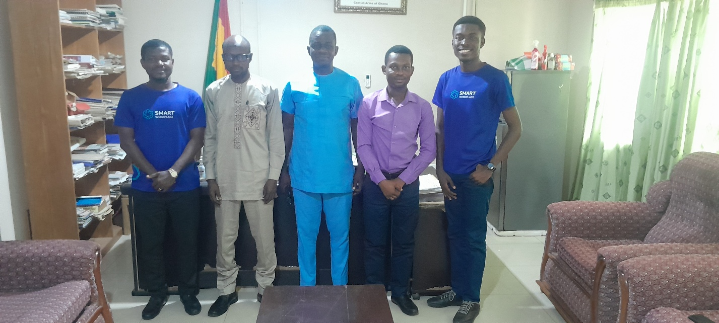
PICTURES OF THE SMART WORKPLACE TRAINING
