REPORT

ON

THETRAINING WORKSHOP
FOR HEADS OF DEPARTMENTS & UNITS OF THE KRACHI WEST MUNICIPAL ASSEMBLY
ON PROPER FINANCIAL MANAGEMENT

PREPARED
BY

ONE TIME LOBBYING CONSULTANCY LTD.

Phone: +233206809215
Email: diwura2000@gmail.com
Web: www.onetimelobbyingconsultancy.online

12TH OCTOBER, 2023

Table of Contents
1.0 INTRODUCTION 3
1.1 Background 3
1.2 Workshop Objective and the Expected Outcomes 3
1.2.1 Workshop Objective 3
1.2.2 Workshop Outcomes 3
1.3 Approach and Methodology 3
1.4 Workshop Participants, Venue and Date 4
1.5 Training Workshop Facilitators 4
1.6 Training Workshop Materials 4
1.7 The Content of the Training 4
1.8 Entrance Meeting with Key Assembly Staff 5
2.0 TRAINING WORKSHOP PROCEEDINGS 5
2.1 Training Workshop Day 1 5
2.2 Training Workshop Day 2 6
2.3 Exit Meeting with Key Staff of the Assembly 7
3.0 EVALUATION OF THE TRAINING WORKSHOP 7
4.0 RECOMMENDATIONS AND CONCLUSION 10
4.1 Recommendations 10
4.2 Conclusion 10
APPENDICES 11
Appendix 1: List of Participants 11

1.0 INTRODUCTION

1.1 Background
Krachi West District is one of the eight districts in the Oti Region, Ghana. It was formerly part of the then larger Krachi District. The then Krachi District was established by Legislative Instruments (LI) 1501 in March10, 1989. This existed until August 4, 2004 when the eastern part was split off to create Krachi East District. This was later elevated to municipal district assembly status to become Krachi East Municipal Assembly in 14th November, 2017. Thus the remaining part was renamed Krachi West. The administrative and political jurisdiction of former Krachi District has since undergone remarkable changes.

As part of their periodical capacity building, the Municipal Assembly contracted One Time Lobbying Consultancy Limited to conduct a One-day training workshop for its Municipal Finance Officer, Municipal Works Engineer, Municipal Planning Officer, Municipal Budget Analyst, Internal Auditor, Municipal Human Resource Manager, Municipal Social Development Officer, Municipal Physical Planning Officer, Assistant Director IIBs, Municipal Agric Director, District Coordinating Director and all the staff at the Finance Department at its Assembly Hall on 12th October, 2023.

1.2 Workshop Objective and the Expected Outcomes

1.2.1 Workshop Objective
The objective of the training was to upgrade the knowledge of Executive Heads listed above on Financial Management.

1.2.2 Workshop Outcomes
The training course was designed to enable participants to:
- Define the concept of Financial Management and the skills required to manage funds of the Assembly.
- Know the types of financial management techniques.
- The key actors in Financial Management
- Know the characteristics of Financial Management.
- •Understand Process of Financial Management.
- Identify different sources of funds for Municipal/District Assemblies.
- Apply monitoring & evaluation methods.

1.3 Approach and Methodology
The team adopted participatory approach to all activities during the training workshop. To ensure quick and more lasting results, participants were actively involved in the training activities from the beginning to the end.

PowerPoint presentation, questions and answers, brainstorming, plenary discussions, and experience sharing were the methods employed during the training.

1.4 Workshop Participants, Venue and Date
Fifteen (15) persons attended the training. Two females and thirty males. The list of participants can be found in appendix one (1) of this report.

The training was organized at the Assembly Hall of the Krachi West Municipal Assembly on 12th October, 2023.

1.5 Training Workshop Facilitators
The facilitators for the training workshop was by a team of consultants from One Time Lobbying Consultancy Limited, Accra. The team comprised Mr. Hassan Diwura, the lead facilitator; and Mr. Desmond Kaledzi, the rapporteur.

1.6 Training Workshop Materials
The materials used during the workshop were the following:
- Power point slides
- Handouts
- Overhead projector
- Laptop computer
- Flip chart sheets
- Flip chart board
- Markers
- Food and drinks

The training was designed in such a way that the participants were actively involved in every aspect of it.

1.7 The Content of the Training
The training was on financial management. The key contents of the training workshop include:
- Introduction to Financial Management.
- The sources of funds for Municipal/District Assemblies.
- How to Manage Funds.
- Key Actors of Financial Management
- The purpose of financial appraisal
- Why there should be financial monitoring and evaluation.
- Accountability of Public Funds

1.8 Entrance Meeting with Key Assembly Staff
The One Time Lobbying Consultancy LTD had a meeting with the Municipal Chief Executive, the Municipal Coordinating Director, the Human Resource Manager, the Procurement Officer, and the District Finance Officer prior to the meeting.
The meeting was to discuss the schedule for the training and the expectations of consultants. The Chief Executive gave assurance, that the every necessary logistics would be provided and that, the Assembly will support the workshop to ensure, that the training was successfully conducted.

2.0 TRAINING WORKSHOP PROCEEDINGS
The training workshop was organized for two days at the Assembly Hall of the Krachi West Municipal Assembly at Kete-Krachi in Oti Region. The training commenced on the 12th of October, 2023. The proceedings of the training workshop was follows:

2.1 Training Workshop-First Session
The training commenced at exactly 9:00 am at the Krachi West Municipal Assembly Hall.
The facilitators welcomed the participants and introduced themselves after an open prayer, and assured them of a fruitful training session. Participants were then asked to introduce themselves by mentioning their full names and designations.

The introduction of participants preceded with the setting up of rules governing the training. The class representative was then elected to provide logistical and timekeeping support, among others. Participants were subsequently taken through the workshop objectives and expectations. The lead facilitator, Mr. Hassan Diwura, indicated that the objective of the training was to upgrade the knowledge of participants in Financial Management. The training was also intended to equip participants with the skills for managing funds in the Krachi West Municipal.

The participants were taken through the definition of Financial Management. The facilitator defined Financial Management as concerned with profitability, expense, cash and credit. Thus, Financial Management means planning, organizing, directing and controlling the financial activities of an organization.
He also took them through the characteristics of Financial Management. According to him, the following are the characteristics of Financial Management:
- Analytical Thinking and follow trend of actual figures and ratio.
- Carry out Decisions
- Continuous Process
- Designs Capital Structure
- Check Financial Needs
- Manage the working capital
- Profit Maximization

Finally, he took them through Funds Identification, Funds Appraisal, Capital financing.

At the end of the presentation, participants were tasked to ask questions, make inputs and suggestions, or comments on the presentations. The First Session of the training ended at 12:00 pm.

2.2 Training Workshop-Second Session
Second Session of the training workshop took off around 1:30 pm. After the facilitator has welcomed the participants, the second session activities began with a recap of first session of the training. All participants were actively involved in the recapping. Each participant was asked to mention at least one thing he or she could remember from the First Session training activities. Responses from participants indicated that they understood and appreciated session one training activities.

After the recap session, the facilitator introduced the participants to financial management Cycle. He said, Financial Cycle is a logical sequence in which the funds are identified, prepared, approved and implemented.
He said that, thin all institutions the cycle shares three common themes:
The cycle defines the key decisions, information requirements and responsibilities at each phase;

The phases in the cycle are progressive – each phase needs to be completed for the next to be tackled with success.
The cycle draws on evaluation to build experience from existing projects into the design of future projects.

Mr. Hassan also introduced them to Financial Cycle Management. He said that Financial Cycle Management is an approach used to guide management activities and decision-making procedures during the life-cycle of a financial management, from the first idea until the last ex-post evaluation.

The facilitator concluded the session by recapping First and Second sessions. He then told the participants to ask for clarifications in areas they didn’t understand. After the questions and answers session, training manuals and handouts were shared among the participants. Participants were advised to go through the materials to deepen their understanding of the knowledge they had acquired from the training.
The training ended at 3:30 pm with a closing prayer.

2.3 Exit Meeting with Key Staff of the Assembly
At the end of the training workshop, the One Time Team of consultants had a meeting with the Municipal Chief Executive, the Municipal Coordinating Director, the Human Resource Manager, the Municipal Finance Officer, and the Procurement Officer to discuss the outcome of the training workshop.

The Consultant informed the meeting of the completion of the training and advised that periodic training programs should be organized for staff in other areas of their work to improve their work performance. Similarly, they were advised to motivate staff by supporting them with the requisite logistics.

The Municipal Chief Executive on the other hand, expressed satisfaction for the training provided by the consultant and hoped that staff will make use of the knowledge they had acquired from the training workshop.

3.0 EVALUATION OF THE TRAINING WORKSHOP
To assess the achievement of the training output, the facilitator asked the participants to assess the training workshop in the following areas:
- Overall Achievement of workshop objectives
- The extent to which the Workshop Expectations were met
- Facilitators Courtesy, Promptness and Delivery.
- Participation and Involvement of the Participants.

The following were the results of the evaluation:

Achievement of Workshop Objectives
13 % of the participants rated the achievement of the workshop objectives as excellent; 67% said it was very good; 13% said it was good; whilst 7% indicated it was fair. Figure 1 show the perception of participants about the achievement of workshop objectives.

Figure 1: Achievement of Workshop Objectives

Extent to Which Participants Expectations Were Met
20% of the participants rated the extent to which their expectations were met as excellent; 53% said it was very good; whilst 27% said it was good. Figure 2 shows a pictorial view of participants’ response to the extent to which their expectations were met.

Figure 2: Extent to which participants’ expectations were met

Facilitation and Delivery
Figure 3 shows participants’ responses to the performance of the facilitator in terms of facilitation and delivery, development of practical skills and impartation of knowledge. Participants described the training as practical, interactive, very insightful, and successful.

20% of the participants rated the facilitation and delivery of the workshop as excellent; 33% indicated it was very good; another 33% said it was good; whilst 13% indicated it was fair.

Participation and Involvement of Participants
27% of the participants rated the level of participation and involvement as excellent; another 27% said it was very good; 33% said it was good; whilst 13% said it was fair. Figure 4 shows a pictorial view of responses on participation and involvement of participants.

Figure 4: Participation and involvement of participants

4.0 RECOMMENDATIONS AND CONCLUSION

4.1 Recommendations
We wish to recommend that:
- Training programs of such nature improve the capacity and work performance of staff, the Assembly should increase the budget for capacity building to organise more of trainings periodically.
- The number of the participants should increase to include more women.
- The participants should share the knowledge and the information they had acquired with colleagues and sub-ordinates who could not participate in the training workshop for the benefit of all the Assembly members.

4.2 Conclusion
There was the general impression, that the training program was successful and satisfactory as expressed by the participants, as indicated in the evaluation exercise.

APPENDICES

Appendix 1: List of Participants
S/N | NAME | DESIGNATION
1 | HON. EMMANUEL KAJAL JALULAH | MCE
2 | ALHASSAN HAMZA | MCD
3 | WISDOM GERALDO | PROCUREMENT
4 | CHRISTOPHER MENSAH HEDEDZI | PHYSICAL PLANNING
5 | BRANTUO ERNEST BOSOMPEM | STATISTICS
6 | KELLY BERNARD | ADIIB
7 | BRIGHT AKOMPIM | HRM
8 | DAVID TSEKPO | ADIIB
9 | JOHN NUNEKPEKU | ENGINEER
10 | JOSEPH ADUSEI ATTA | AGRIC
11 | VERONICA BOAME | BAC
12 | DONKOR BETHUEL | I.A
13 | BOBSON ADAWOROMAH | DEHO
14 | DOE THOMAS | SOCIAL WELFARE
15 | EMMANUEL KPAWUL | ADBA
16 | SETH OKAI AFFUM | MFO
17 | FAUSTINA KAFURI NYASSAM | ACCOUNT OFFICER
18 | JAMES KANGELE | ASST. ACCOUNTANT
19 | SAANI SADIQ | ASST. ACCOUNT TECHNICIAN

Appendix 2: Pictorial Evidence
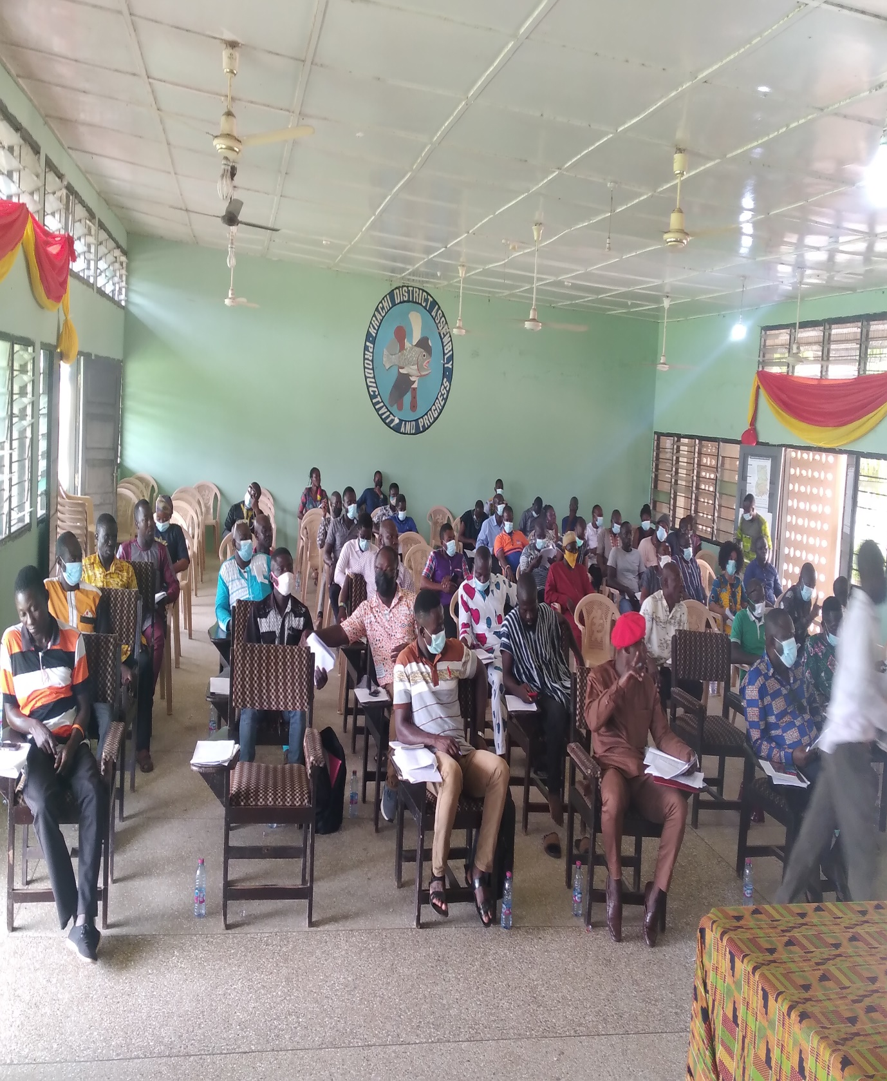

Appendix 3: Pictorial Evidence
